

**Process Book – Data Visualisation**

Course Code: COS30045

Unit Name: Data Visualisation

Unit Assessment Name: Data Visualization Process Book

Title of Project: Suicide Rates between Europe and Asia

Group Number: Group 22

Group Member: Bryan Chow Hou Nam (105189496)

Ng Kang Jen (105002263)

Hoo Ying Kit (105190469)

Submission Date: 15/11/2024

Due Date: 15/11/2024

Word Count: 5564 words

Year & Semester: Year 1, Semester 2  
Website Link: <https://cos30045group22.github.io/Assignment2/index.html>

**Table of Content**

1.0 INTRODUCTION 2

1.1 BACKGROUND AND MOTIVATION 2

1.2 VISUALISATION PURPOSE 3

2.0 DATA 4

2.1 DATA SOURCE 4

2.2 DATA PROCESSING 13

3.0 VISUALIZATION DESIGN 24

3.1 Early Ideas of our Visualizations 24

3.2 Finalized Designs 30

4.0 VALIDATION 37

5.0 CONCLUSION 39

6.0 REFERENCES 40

7.0 APPENDICES 41

43

# 1.0 INTRODUCTION

## 1.1 BACKGROUND AND MOTIVATION

Suicide is a pressing global issue that impacts families, communities, and societies. In both Asia and Europe, suicide rates vary significantly due to cultural, social, and economic factors. This project seeks to provide a deeper understanding of suicide patterns, highlighting trends across these two regions. Policymakers, mental health professionals, NGOs, educators, and the public can use the insights from this visualization to address mental health challenges more effectively.

This project is crucial for several reasons:

* **Government agencies and policymakers** can identify areas with the highest suicide rates, guiding resource allocation and preventive strategies.
* **Mental health professionals** can use the data to target high-risk demographics and regions.
* **NGOs** can leverage the findings to advocate for policy changes and raise awareness.
* **Researchers and students** studying sociology, psychology, and public health can utilize the visualizations for academic purposes.
* **The general public** can gain insights into suicide trends, encouraging open discussions about mental health.

## 1.2 VISUALISATION PURPOSE

The purpose of the visualizations is to answer specific questions, such as:

1. How do suicide rates compare between Asia and Europe?
2. Which countries or regions have the highest and lowest suicide rates?
3. How have these rates changed over time in each region?
4. Which demographic groups, based on age or gender, are most affected?
5. Is there a link between socioeconomic factors and suicide rates?

The visualizations aim to make the data accessible and engaging. By presenting various unique visualizations like circular heat map, bubble chart, and mosaic plot, users can explore relationships, patterns, and trends. This interactive approach supports better decision-making for stakeholders, raises public awareness, and contributes to reducing the stigma surrounding mental health. The inclusion of a map visualization also helps users identify geographical clusters and hotspots, making complex data easier to comprehend.

# 2.0 DATA

2.1 DATA SOURCE  
  
The data used for this project is sourced from OECD health website and several other data websites containing suicide statistics. Other than OECD, we made sure to use websites that are reliable and trustworthy to get statistics about suicide such as Kaggle, WHO, and United Nations. These websites provide us with statistical data that relates to multiple categories of suicide such as different age groups suicide, countries vs countries suicide rate, and income level countries suicide rate all compared between Asia and Europe. The wide range of information available allowed us to visualize the trends and patterns of suicide across Asia and Europe more effectively. It is our objective to help users to understand why this issue is a serious one through a technical approach of collecting data and analyzing it, which is important for data validation and providing valuable insights on suicide patterns in Asia vs Europe.

For our analysis, we did it with several CSV files, each relates to a different category of suicide rate

* Source of Asian and European Countries suicide rates (number-of-deaths-from-suicides-ghe.csv) The CSV file has the following field and datatypes:

number-of-deaths-from-suicides-ghe.csv

|  |  |
| --- | --- |
| **Column Names** | **Datatypes** |
| Country name | Categorical |
| Suicide Rates | Ratio |
| Year | Numerical |
| Country Code | Categorical |

For this csv example, Country name, Suicide rates, Year and Country code are included in the column names. As for the data types, both Country name and Country code will represent Categorical as the data types. Suicide rate’s datatypes will be ratio as the amount of people suicide will be according to 100,000. And for the year’s datatype, Numerical will be used.

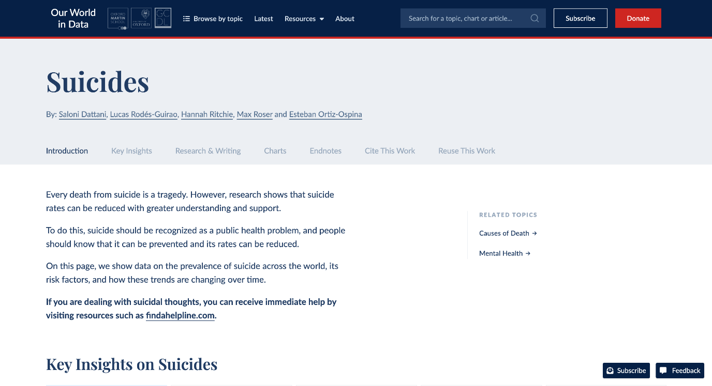(Figure 1: the dataset for the map is obtained from Our World in Data Website [Data Source)](https://ourworldindata.org/suicide)

In this website, the number of datasets is tremendous. We have to scroll through all the datasets to find which datasets are the best fit to the map. As we came across one dataset that is number of suicide comparison. We took the datasets and implemented them to our world map.

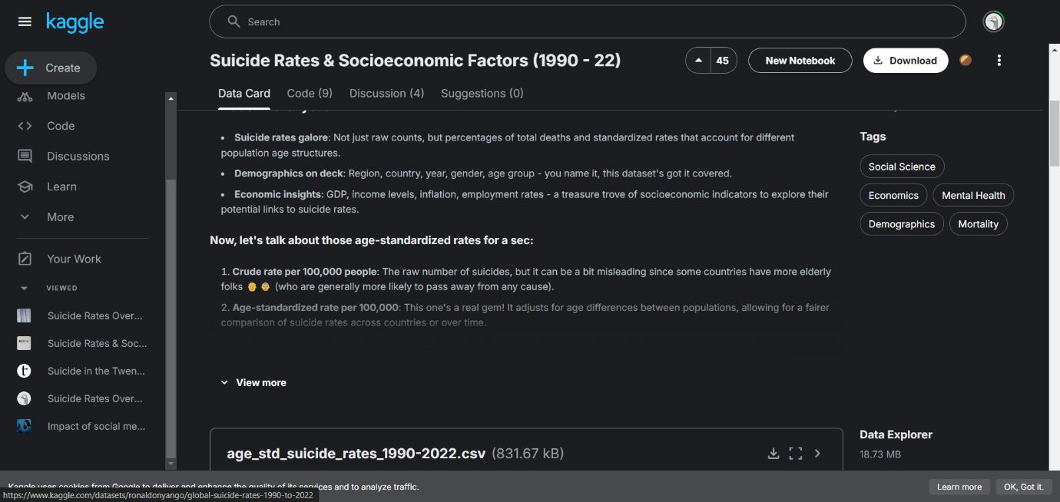(Figure 2: Kaggle website where I got the unfiltered version of income.csv - Data Visualization 1 [(Data Source)](https://www.kaggle.com/datasets/ronaldonyango/global-suicide-rates-1990-to-2022)

The following figure is where I got the age_std_suicide_rates_1990-2022.csv which is the unfiltered version of income.csv. Kaggle is a reputable website for Data Scientists. The file that is on the website is already in a CSV format, but it is not filtered. We filtered and cleaned it and changed it into income.csv. The filtering process that we did will be discussed further in the next section which 2.2 Data Processing

* Source of high, low, upper-middle, lower middle income level countries suicide rates in Asia vs Europe (income.csv) The CSV file has the following field and datatypes:

Income.csv

|  |  |
| --- | --- |
| Column Names | Datatypes |
| Region Name | Categorical |
| Country Name | Categorical |
| Year | Numerical |
| Sex | Categorical |
| Suicide Count | Numerical |
| DeathRatePer100k | Numerical |
| Income Level | Categorical |

The RegionName column represents categories of regions (e.g., Asia, Europe). No intrinsic ordering exists between these categories. The CountryName column represents countries that are in either of the countries. No intrinsic ordering exists here either. The Year column is a numerical field representing the year. It is treated as an interval variable because the difference between years is meaningful, but it lacks a true zero. The Sex column represents the gender (e.g., Male, Female). No ordering exists between the categories. The SuicideCount column represents a count of suicides, making it a discrete numerical variable. The DeathRatePer100k column is a rate value, making it a continuous numerical variable. The IncomeLevel column represents the income level (e.g., High, Upper-Middle, Lower-Middle, Low). There is a meaningful order among these categories, making it ordinal.

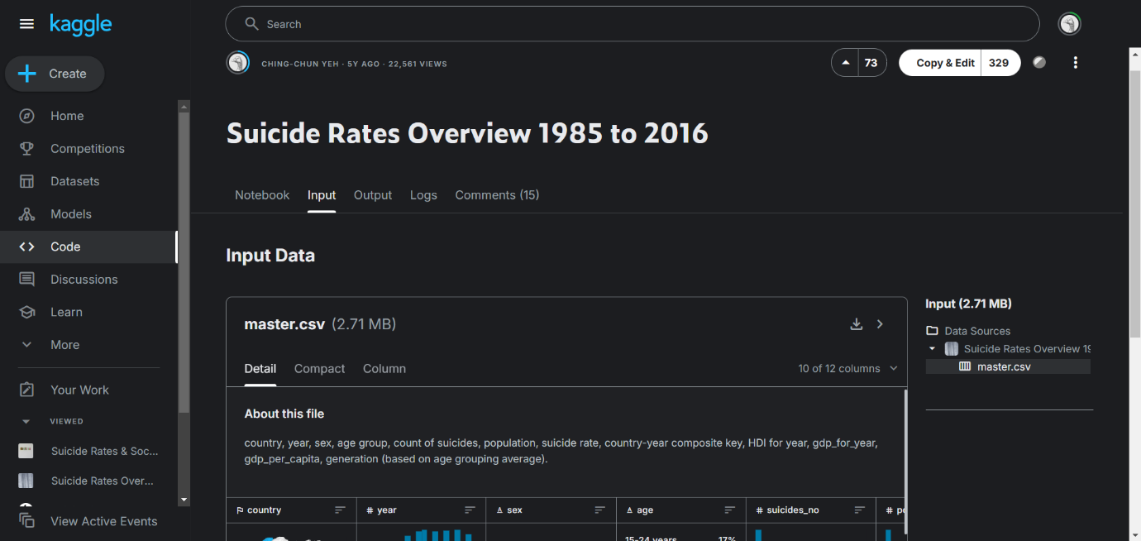(Figure 3: Kaggle website where I got the unfiltered version of generation.csv - Data Visualization 2 [(Data Source)](https://www.kaggle.com/datasets/russellyates88/suicide-rates-overview-1985-to-2016)

The following figure is where I got the master.csv which is the unfiltered version of generation.csv. Kaggle is a reputable website for Data Scientists. The file that is on the website is already in a CSV format, but it is not filtered. We filtered and cleaned it and changed it into generation.csv. The filtering process that we did will be discussed further in the next section which 2.2 Data Processing

* Source of generations suicide rates in Asia vs Europe (generation.csv) The CSV file has the following field and datatypes:

generation.csv

|  |  |
| --- | --- |
| **Column Names** | **Datatypes** |
| region | Categorical |
| generation | Categorical |
| sex | Categorical |
| year | Numerical |
| suicides_no | Numerical |
| population | Numerical |
| suicides_per_100k | Numerical |

The region column represents regions (e.g., Asia, Europe). No intrinsic ordering exists. The generation column. The sex column represents gender (e.g., Male, Female). No ordering exists. The year column is a numerical field representing the year. Treated as an interval variable since the difference between years is meaningful, but there is no true zero. The suicides_no column represents the count of suicides, making it a discrete numerical variable. The population column represents the population of that particular demographic group, making it another discrete numerical variable. The suicides_per_100k column is a calculated suicide rate per 100,000 people, making it a continuous numerical variable.

* Source of different age groups suicide rates in Asia vs Europe

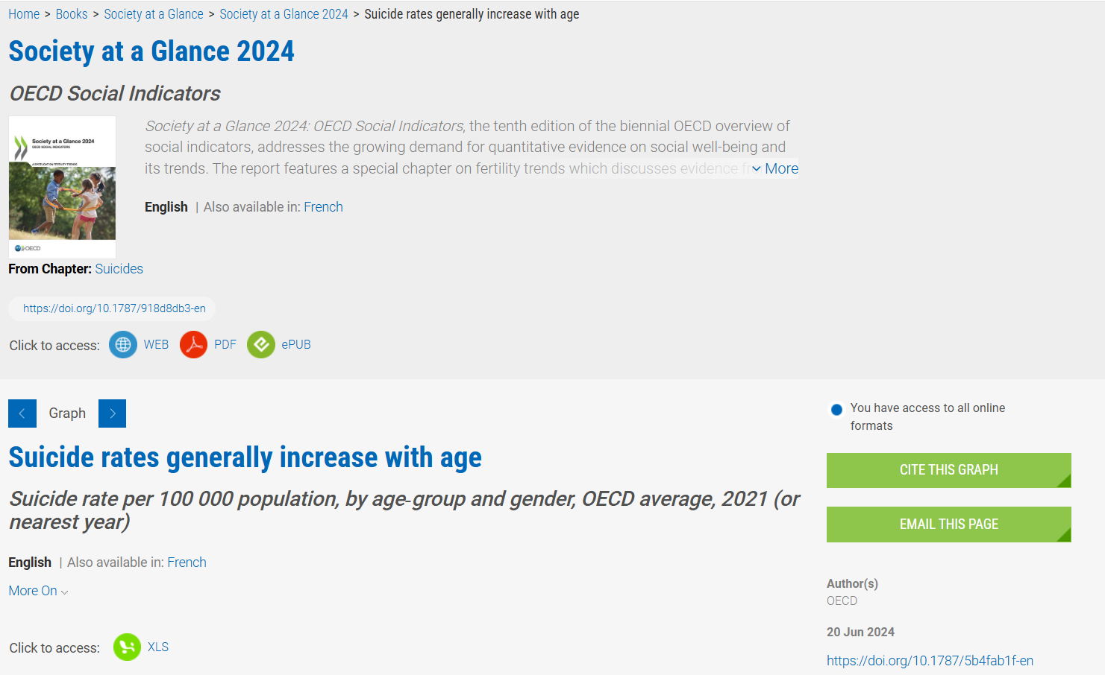(Figure 4: Data Visualization 3 – Age Group - [Data Source)](https://www.oecd-ilibrary.org/social-issues-migration-health/suicide-rates-generally-increase-with-age_5b4fab1f-en)

The figure above shows the suicide rates per 100,000 people, categorized by gender and age group, across different years. The data source can be found on the OECD, a trusted website that focuses on global health trends. The most recent update was in 2024, making it current and reliable. The original dataset was provided in an Excel file, mainly formatted as tables for easy viewing. However, we converted it into a CSV file after filtering the data, which is more convenient for coding and data analysis.

* The CSV file (oecd.csv) has the following field and datatypes:

|  |  |
| --- | --- |
| **Column Names** | **Datatypes** |
| Country | Categorical |
| Continent | Categorical |
| Age Group | Categorical |
| Suicide Rate | Numerical |

At first, the Country column consists of various names of countries in the dataset. The Continent column includes Asia and Europe, which are the primary regions of comparison in our project. The Age Group column covers various age ranges, starting from 15-19 and going up to 85+. The Suicide Rate column indicates the rate per 100,000 population, represented as ratio numerical data. In order to make the CSV file cleaner and easier to deal with, we deleted lots of columns and unneeded data. The details of this data cleaning procedure are described in the data processing section below.

* Source of different suicide methods used in Asia vs Europe

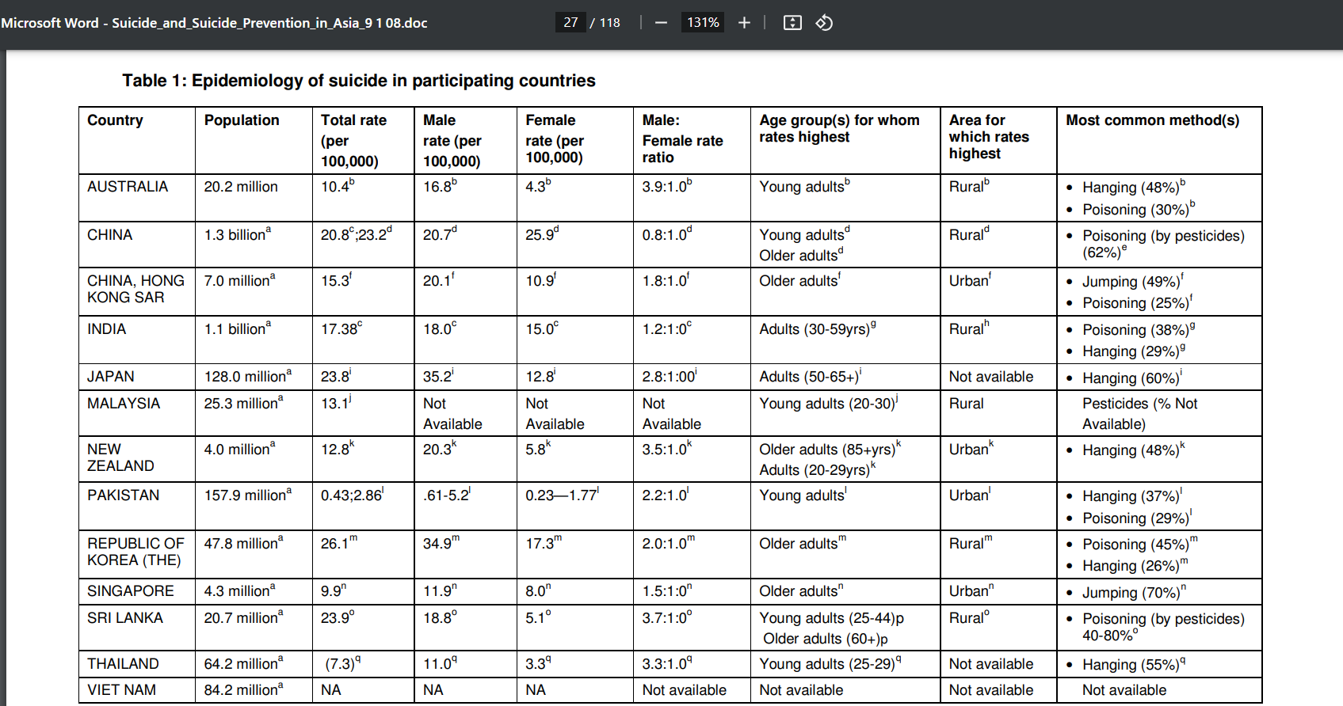(Figure 5: Data Visualization 4 – Suicide Method - [Data Source 1](https://iris.who.int/rest/bitstreams/52201/retrieve))

The figure above shows suicide rates in several Asian countries, organized by population, gender, age group, area, and common suicide methods. The data comes from the World Health Organization (WHO), a United Nations body that monitors global health and promotes good health standards around the world.

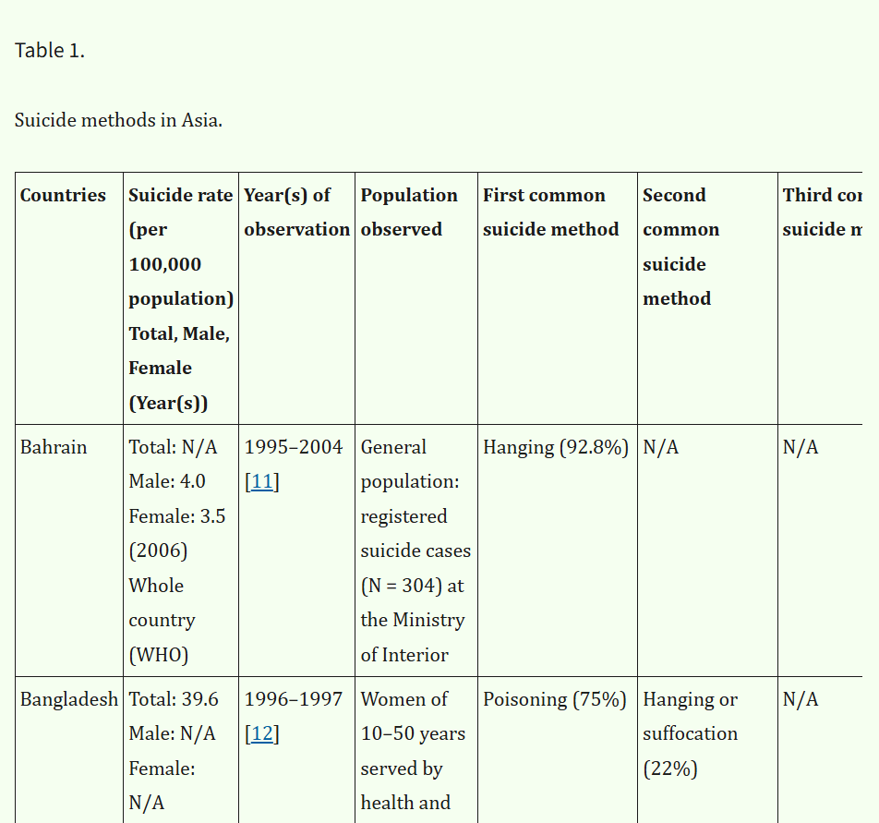

(Figure 6: Data Visualization 4 – Suicide Method - [Data Source 2](https://pmc.ncbi.nlm.nih.gov/articles/PMC3366604/#sec2))

The figure above presents suicide rates and common methods used in various Asian countries. In order to obtain more information about suicide methods in Asia, we used PubMed Central (PMC) as a source, rather than just relying on Data Source 1, which provided only limited data.

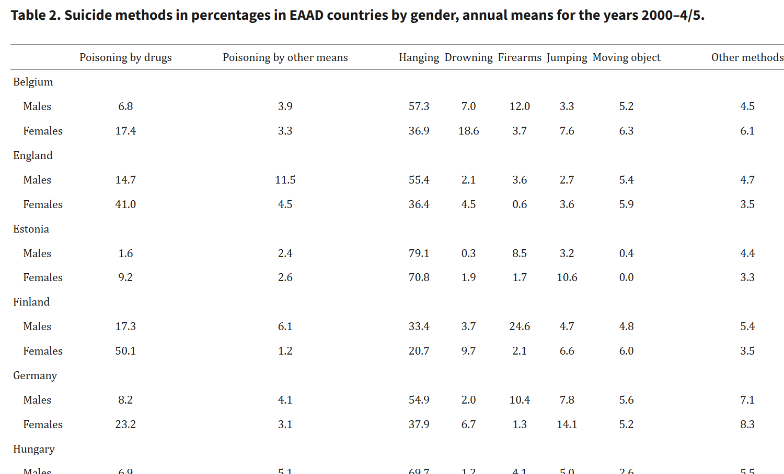(Figure 7: Data Visualization 4 – Suicide Method - [Data Source 3](https://pmc.ncbi.nlm.nih.gov/articles/PMC2569832/table/HZT-62-06-0545-t02/))

The figure above shows suicide methods categorized by gender in European countries. This data source is based on PubMed Central (PMC), which includes various articles from the National Library of Medicine in the United States. Besides, since all of these 3 original tables contained unnecessary columns, we cleaned and filtered the data to produce a clear CSV file, as shown below.

The CSV file (datavis4.csv) has the following field and datatypes:

|  |  |
| --- | --- |
| **Column Names** | **Datatypes** |
| Country | Categorical |
| Continent | Categorical |
| Drug | Numerical |
| Poisoning | Numerical |
| Hanging | Numerical |
| Jumping | Numerical |
| Other | Numerical |

The first column, Country, represents various country names worldwide. The Continent column includes regions like Asia and Europe, which are the main areas of comparison in our project. Both of these columns are nominal categorical data, which means no specific order, just use as labels to classify content into distinct groups. The remaining columns: Drug, Poisoning, Hanging, Jumping, and Other represent different suicide methods and use numerical data types, as they have a true zero, making them useful for comparisons.

## 2.2 DATA PROCESSING

In this project, most of the datasets that are found either from OECD website or other online website resources are required to perform cleanup or filtering. This is mentioned because, most of the datasets that are retrieved online are scattered around. Each of the group members has to make sure that all the data sets are summarized and clean. To do so, each member has to do filtering to ensure no unnecessary data is included. For example, a dataset contains year, suicide rates, male, female, both gender, country, country code and age group. The topic will be number of suicide rates between Europe and Asia for both genders. According to the topic, male, female and age group data types can be removed as those data types are unnecessary for the chart.

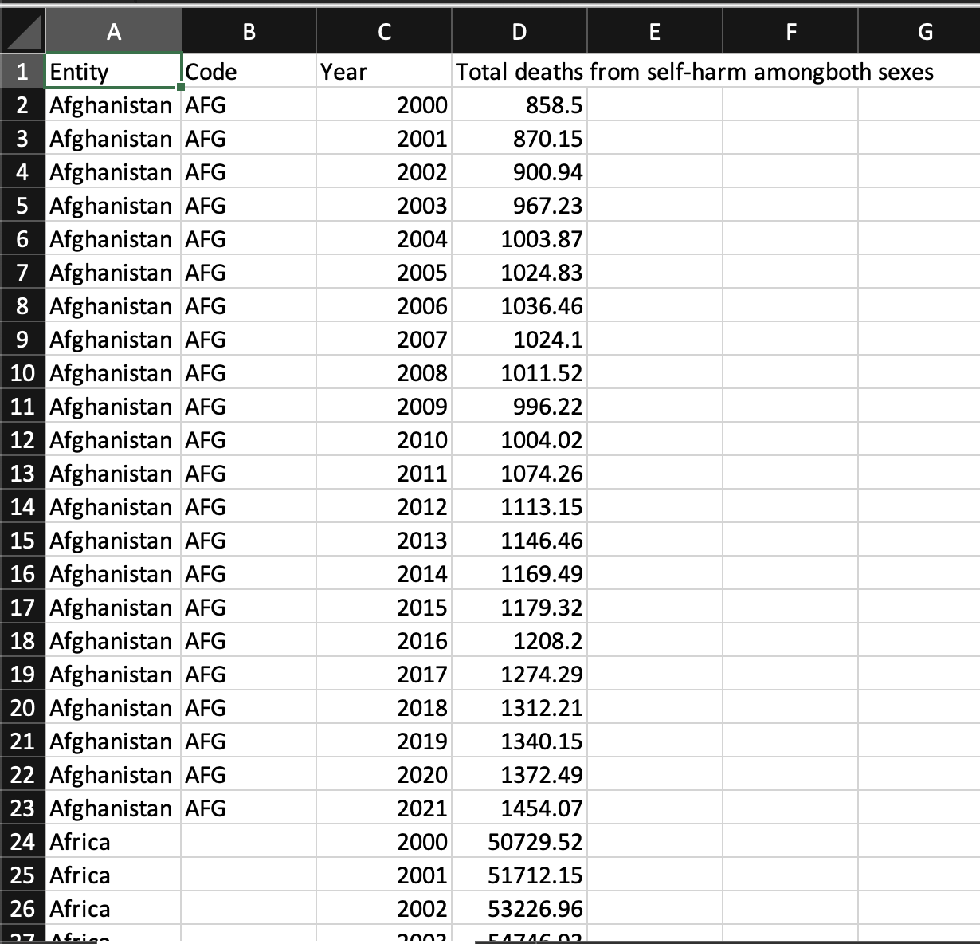  
(Figure 8: number-of-deaths-from-suicides-ghe.csv)

The csv file for number-of-deaths-from-suicides-ghe.csv is already clean when I download the csv file from online source. Countries, country code, year and both genders suicide rate are provided from the online resources. Since the topic of our project is to compare between Europe and Asia. We have to make sure that the dataset doesn't have any other countries except for Europe and Asia. To do this, in the JavaScript file for the map, map.js. We implemented the code by filtering out Europe and Asian countries and presented in data. Other countries besides Europe and Asia have remained as 1 color which is grey, while Europe and Asia have a color scheme gradient to identify the number of suicides.

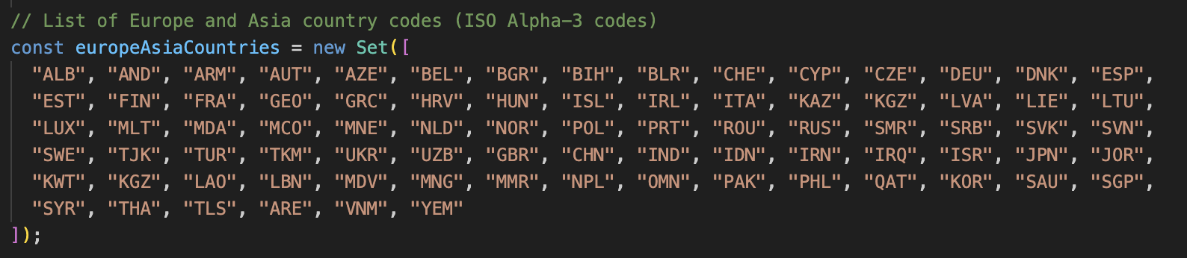(Figure 9: List of Europe and Asia Countries)

According to the figure above, we filter out 1 by 1 of Europe and Asia countries by filtering out the Country code of each country.

The data required substantial cleanup to ensure its accuracy and relevance for the analysis. Both datasets, master.csv and age_std_suicide_rates_1990-2022.csv that I took from the Kaggle website which were the unfiltered version of generation.csv and income.csv, contained unnecessary columns, rows with missing values, and data requiring aggregation to match the project’s scope. Several quantities were derived during processing, including suicide rates per 100,000 population, total suicide counts, average death rates, and aggregated population sums. These quantities were essential for the analysis of suicide rates by generation, region, and income levels.

The data processing was implemented using Python, leveraging the Pandas library for efficient manipulation of structured data. First, unnecessary columns such as country-year, HDI for year, and GDP-related fields were removed from the master.csv dataset, as they were incomplete or irrelevant to the scope of the project. Similarly, for the age_std_suicide_rates_1990-2022.csv dataset, only relevant columns like RegionName, CountryName, Year, Sex, SuicideCount, DeathRatePer100K, and Population were retained. Missing values in key columns, such as DeathRatePer100K and Population, were handled by removing rows with incomplete data, ensuring consistency and reliability in the analysis.

Grouping and aggregation played a critical role in preparing the data for analysis. For the master.csv dataset, the data was grouped by country, generation, sex, and year, with aggregated metrics including total suicide counts, total population, and average suicide rates per 100,000 population. Similarly, the age_std_suicide_rates_1990-2022.csv data was grouped by RegionName, CountryName, Year, and Sex, with derived metrics such as average death rates and total suicide counts. Filtering was then applied to limit the data to countries in Asia and Europe, ensuring alignment with the project's scope.

Several derived variables were crucial for the analysis. The suicide rate per 100,000 population was recalculated during grouping to maintain consistency across comparisons. Total suicides and population sums were aggregated for each group to provide a comprehensive understanding of the relative sizes and impacts. The average death rate per 100,000 was also calculated for income-level comparisons. This structured cleanup process ensured the datasets were well-prepared for the visualizations and analysis required in the project.

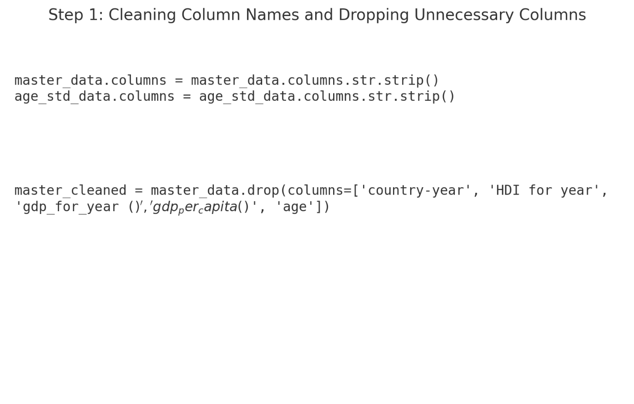  
(Figure 10: Cleaning the master.csv file - Data Visualization 2)

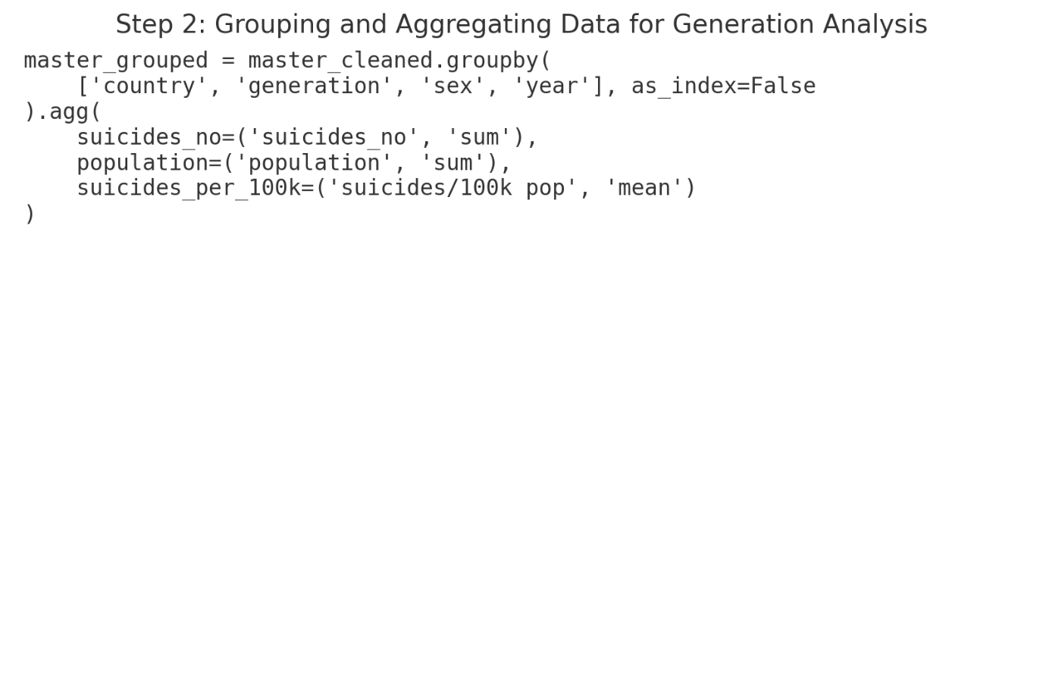

(Figure 11: Grouping the cleaned data of generations for analysis. - Data Visualization 2)

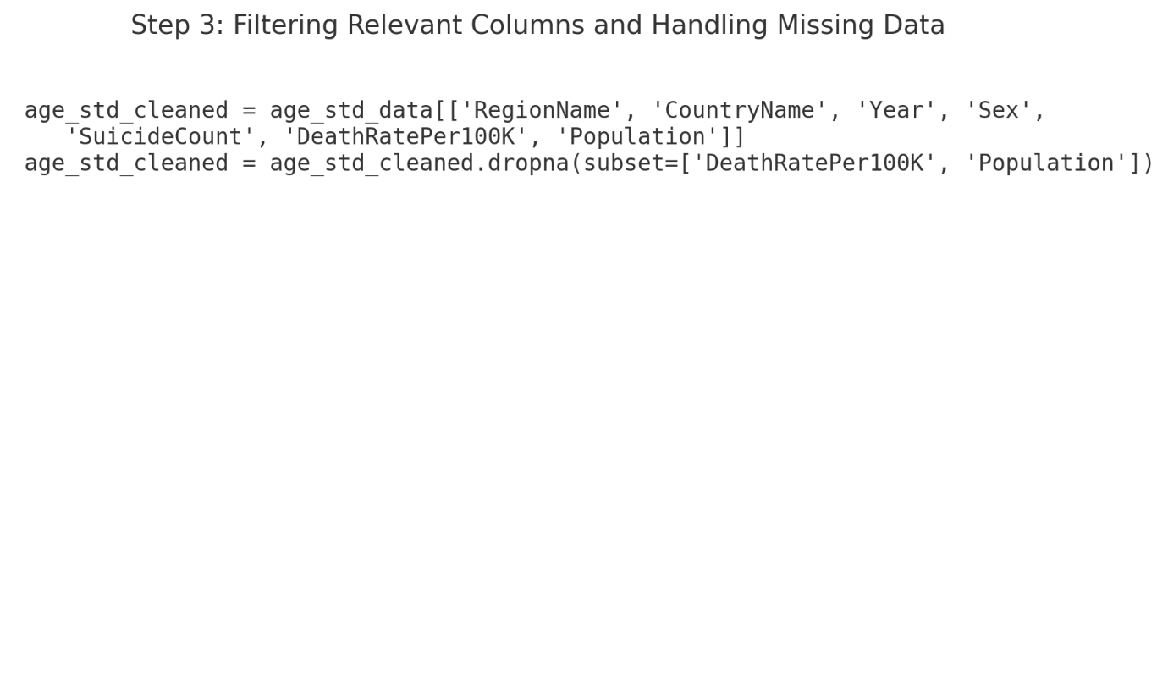  
(Figure 12: Cleaning the age_std_suicide_rates_1990-2022.csv - Data Visualization 1)

(Figure 13: Grouping the cleaned data for income levels for analysis - Data Visualization 1)

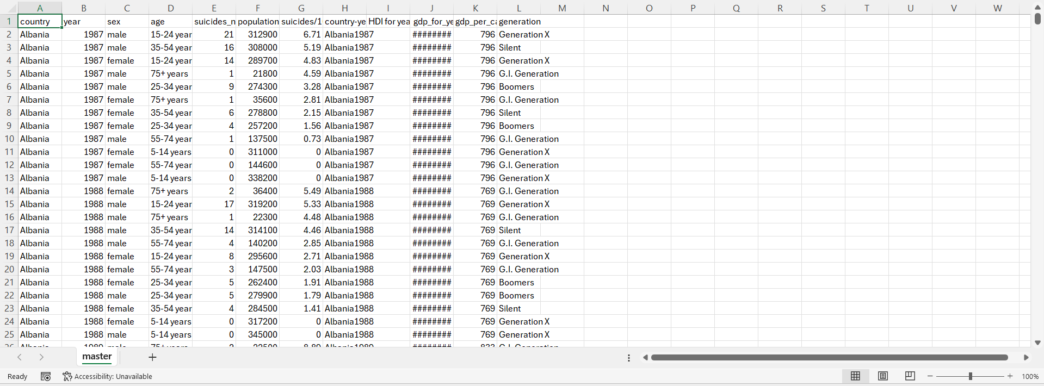(Figure 14: unfiltered version of generation.csv (master.csv) - Data Visualization 2)

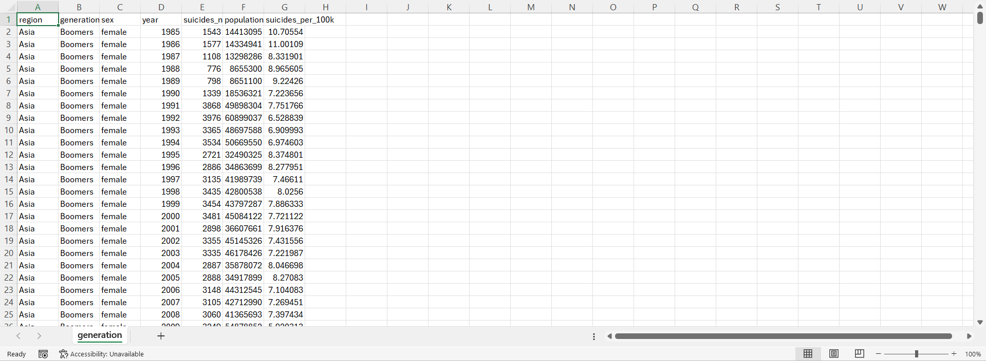(Figure 15: generation.csv - Data Visualization 2)  
  
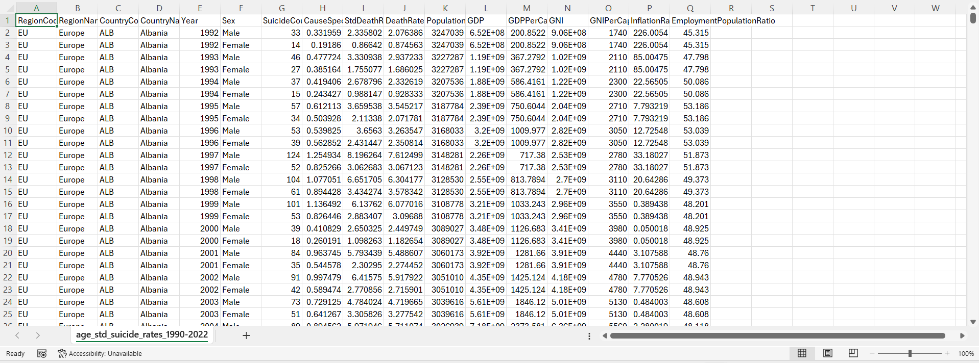(Figure 16: unfiltered version of income.csv ( age_std_suicide_rates_1990-2022.csv - Data Visualization 1)

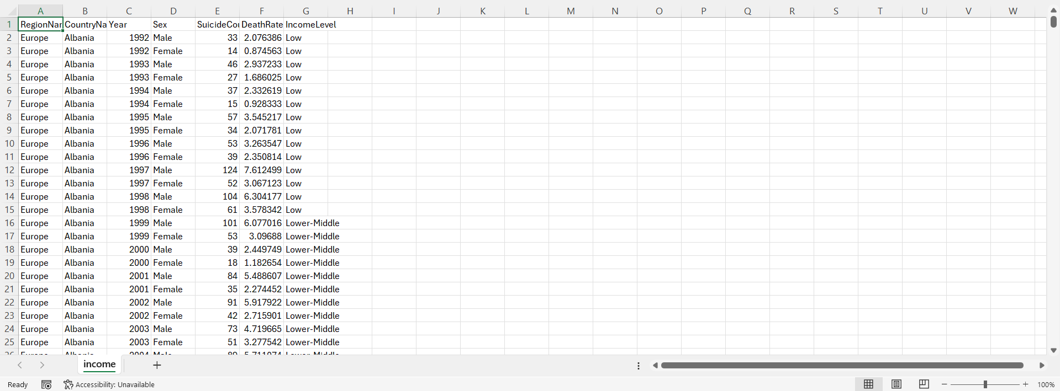(Figure 17: income.csv - Data Visualization 1)

Due to limited information, the original dataset does not contain a large volume of data, such as thousands or millions of entries. However, we still need to filter significant columns to focus on the most relevant data. In order to create a more detailed dataset, we combined three original datasets for data visualization purposes in one of the charts. Although the combined data set is still relatively small, careful filtering remains essential, as some columns do not suit our subtopic. We aim to retain only the columns that effectively represent our subtopic.

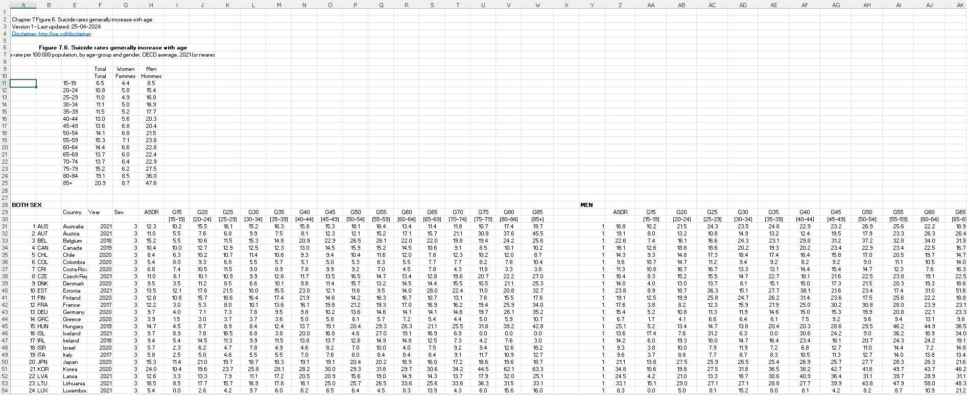(Figure 18: Data Visualization 3 – Age Group Original Dataset)

The figure above shows the original dataset for age groups, including the OECD average suicide rate, gender (both sexes, male, and female), country code, country name, year and suicide rate for various age groups.

Choosing the appropriate columns for our chart: country and suicide rate by age group, is the first step. The country code has been removed, as it is not related to our chart design. To maintain consistency, we have chosen to focus on both sexes, rather than focus on individual genders (male and female). Additionally, since our project mainly concentrates on Asia and Europe, we have excluded countries from other continents.

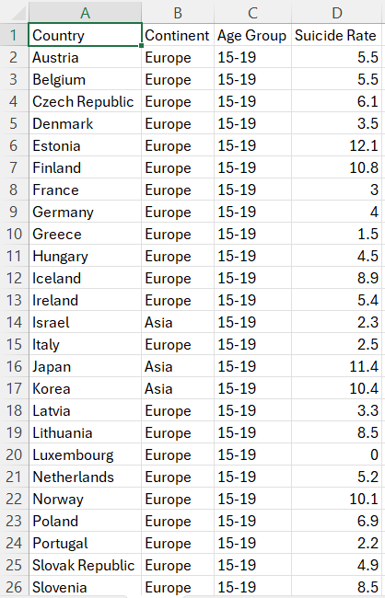

(Figure 19: Data Visualization 3 – Age Group Filtered Dataset)

The filtered dataset used in our third chart is displayed in the figure above after the unnecessary columns have been eliminated. In addition to removing unnecessary columns, we included a “Continent” column to specify whether each nation is in Asia or Europe. This update makes it easier to filter and compare countries by continent within the chart, which will be useful for the code later.

Furthermore, we reorganized the suicide rate by age group into two vertical columns for “Age Group” and “Suicide Rate”. By making it clear that the “Suicide Rate” column relates to each age group, this modification enhances readability and makes it easier for the code to distinguish suicide rate within each age group from the original CSV file. We make sure the data is easy to understand by clearly separating the age group and suicide rate value.

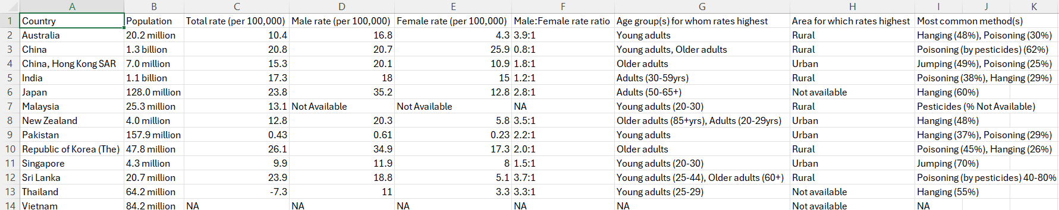(Figure 20: Data Visualization 4 – Suicide Method Original Dataset 1)

The above figure is one of the datasets which are used in the fourth chart: Suicide Method. As shown, the dataset includes a limited number of countries, mostly in Asia, along with details about population, suicide rates by gender, and suicide methods.

We eliminated Australia and New Zealand, as they are not part of Asia or Europe to focus on our visualization topic. Columns for population, rate and age groups were removed, only the Country and Suicide Methods columns remaining.

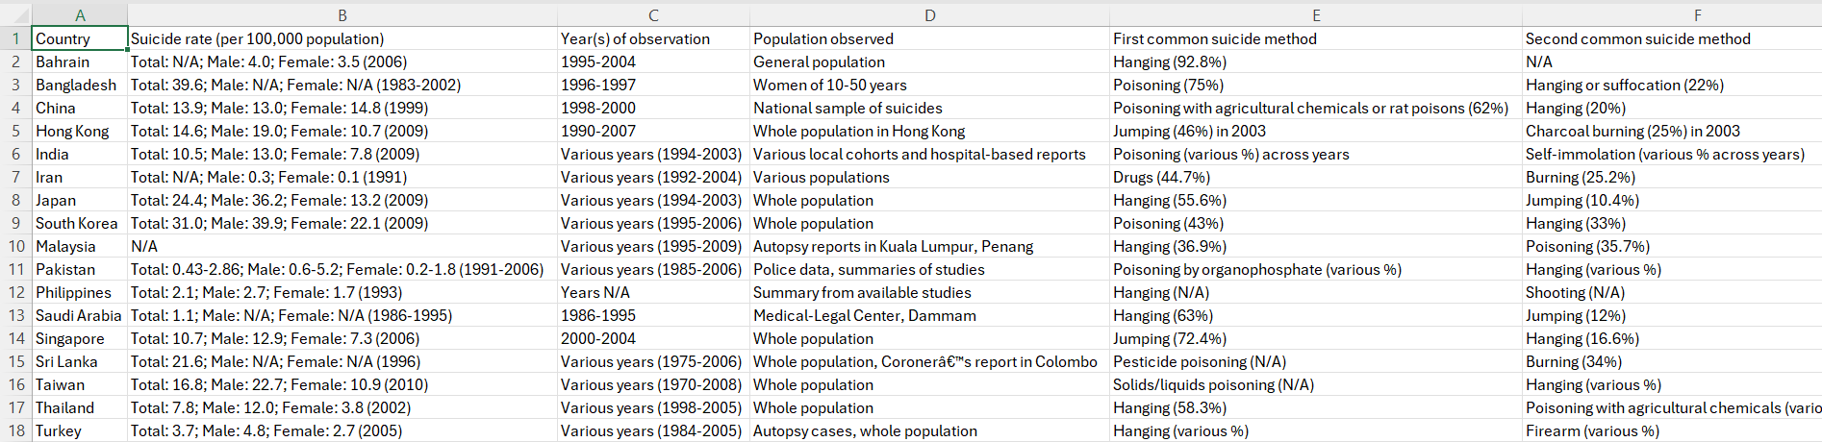(Figure 21: Data Visualization 4 – Suicide Method Original Dataset 2)

The figure above provides an additional source for suicide methods in Asia, offering more detailed information on this subtopic. It also includes data on suicide rates, observation years, and population.

In order to align with our visualization, we retained only the Country and Suicide Method columns, removing other columns that were not relevant.

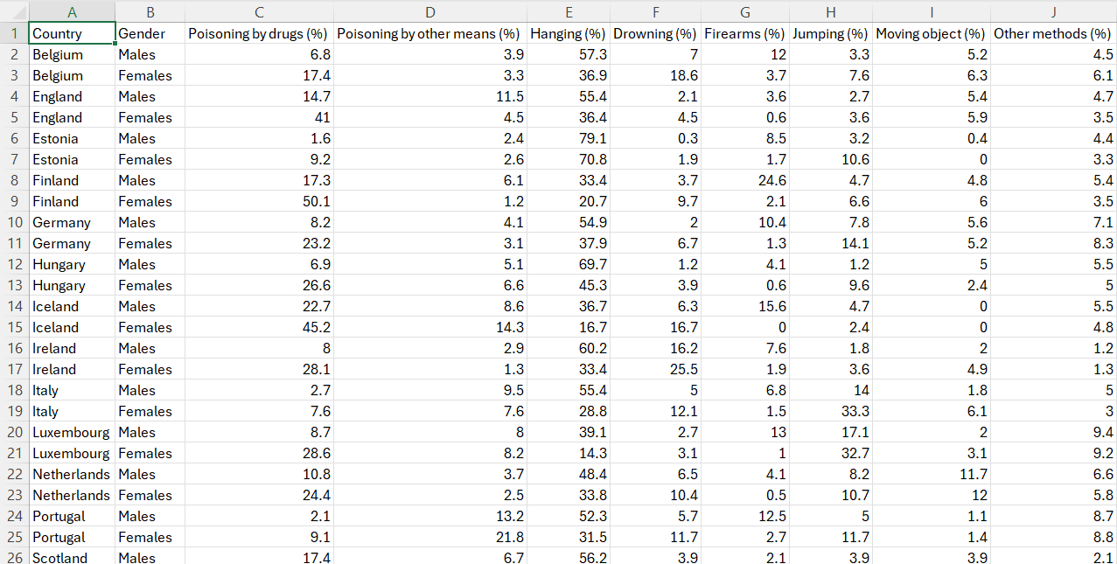(Figure 22: Data Visualization 4 – Suicide Method Original Dataset 3)

The above figure displays suicide methods in Europe with different genders. In order to maintain the consistency to the Asia, we removed Drowning, Firearms, Moving object and Other methods column. Since all of these columns have only appeared in European countries, which may lead to lack of data in Asian countries if we included those in our dataset.

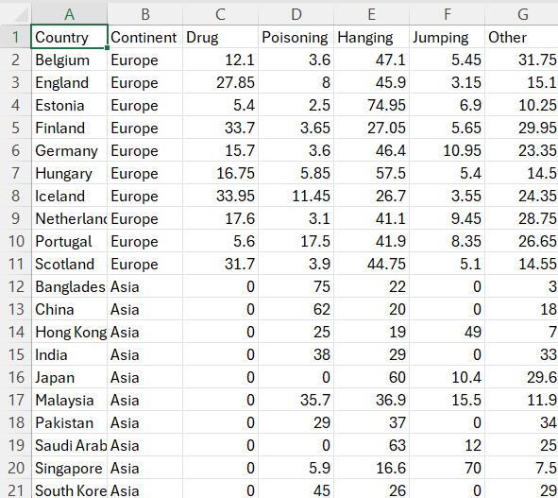

(Figure 23: Data Visualization 4 – Suicide Method Filtered Dataset)

After eliminating irrelevant columns, our fourth chart uses the filtered dataset from the above figure. We added a "Continent" column to show if each nation is in Asia or Europe. The code will benefit from this simplification since it makes it smoother to filter and compare countries by continent within the chart.

Moreover, we have chosen the main common suicide methods from the above data source, which is Drug, Poisoning, Hanging, Jumping and Other. For the calculation of suicide methods in Asia countries, we just get the actual percentage from the original data source. For European countries, where the data is separated by gender, we combined the values for both genders and divided them by two to obtain the average percentage for each suicide method. We determined the percentage for the Other column by subtracting the sum of the percentages for the four most common suicide methods from 100%.

We chose 10 Asian and 10 European countries with the most valid data, making sure that there were nearly equal numbers of countries from each continent. This avoids an imbalance in the number of countries from each continent, ensuring a more even comparison.

# 3.0 VISUALIZATION DESIGN

## 3.1 Early Ideas of our Visualizations

**First Topic:** What is the Suicide Rate compared between Asian countries vs European countries?

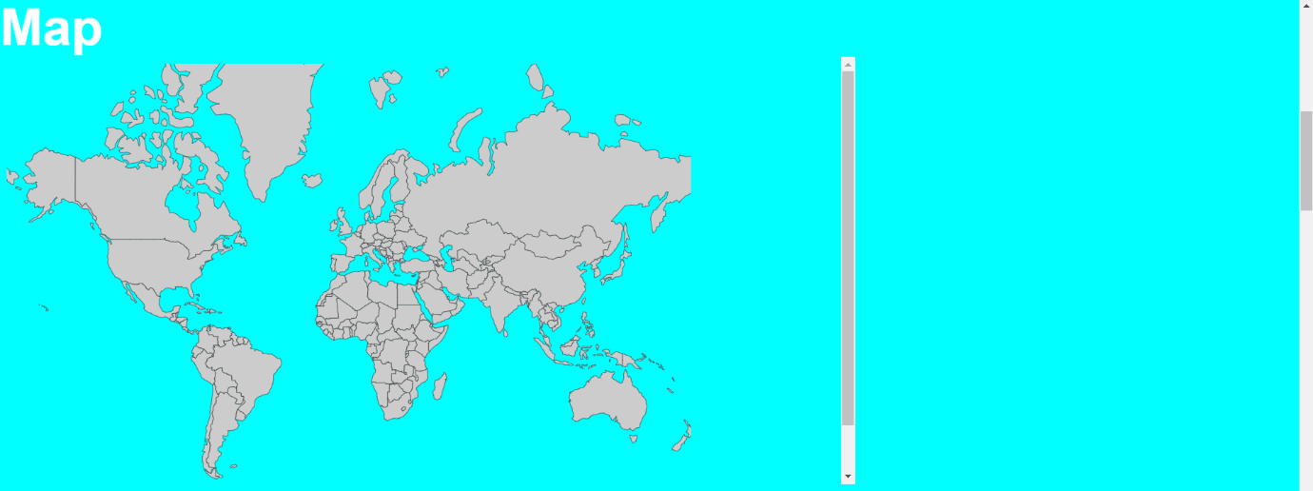(Figure 24: Initial Map visualization to compare between Asian and European countries.)

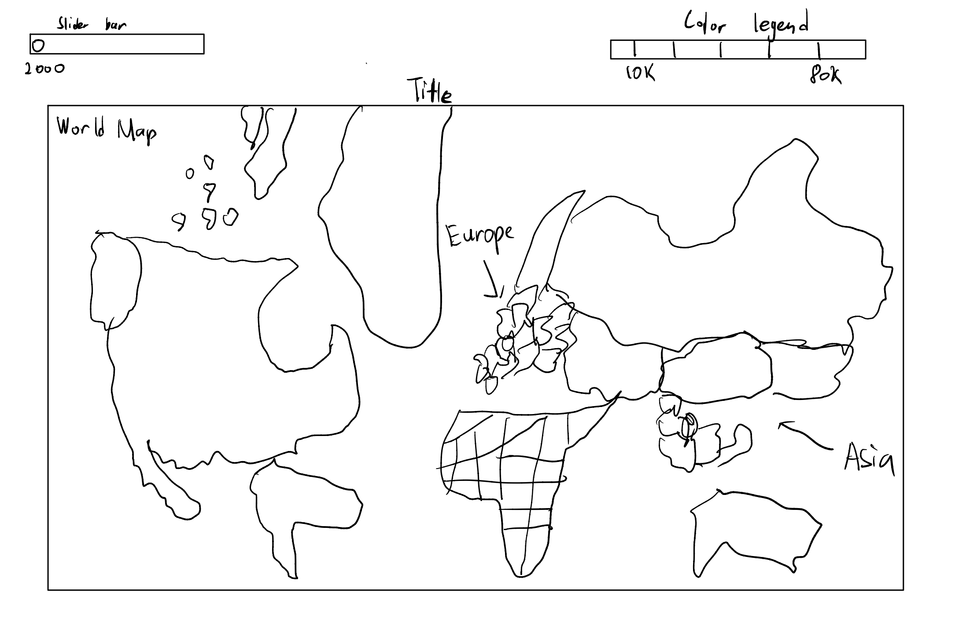(Figure 25: Initial Sketch of the Map)

Initially, we tried to fit an OECD dataset into a map chart but failed to do so. As OECD dataset contains limited amount of data to visualize the map. We changed the dataset to a more resource dataset. We planned to add a slider effect for the year to switch between years.

**Second Topic:** What is the Suicide Rate compared between high, low, upper-middle, lower middle countries in Asia vs Europe?

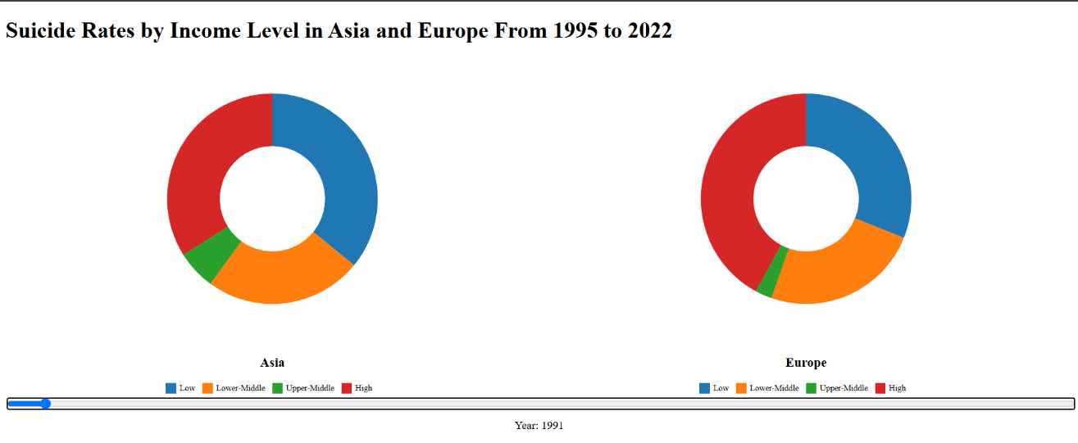  
(Figure 26: Initial Donut Chart)

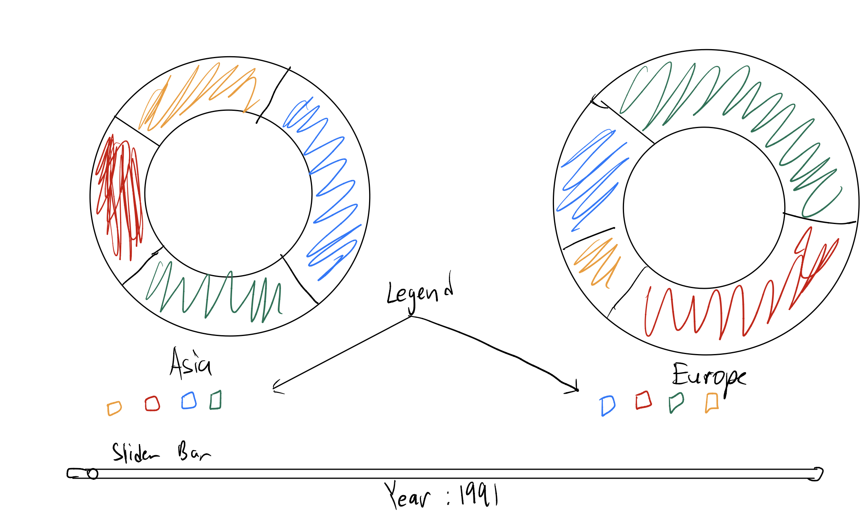(Figure 27: Initial sketch of the Donut Chart)

When we were planning out the visualization, we took the data from Kaggle which is a reputable data website. We used donut charts and a slider because it can outline over time which type of countries are most affected by money that led them to do such things. However, later we realized that the idea is way too simple and basic, so that is why we decided to change it into a Mosaic Plot.

**Third Topic:** What is the Suicide Rate between Generations (e.g. Gen Z, Gen X, and etc) in Asia vs Europe?

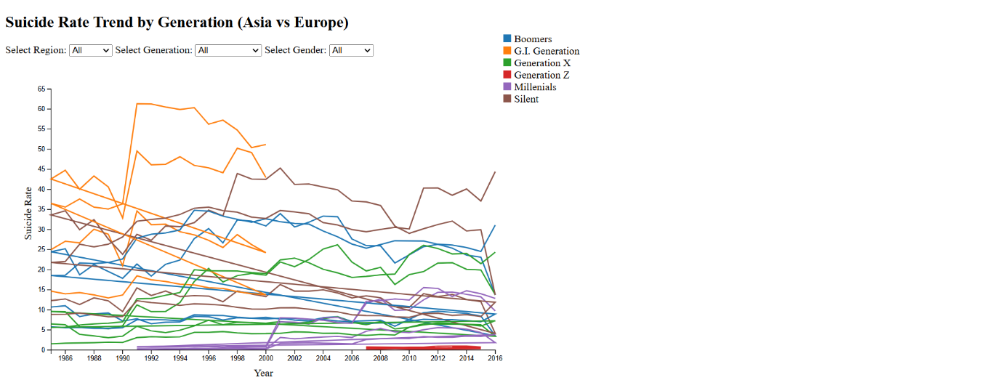(Figure 28: Initial Line Chart)

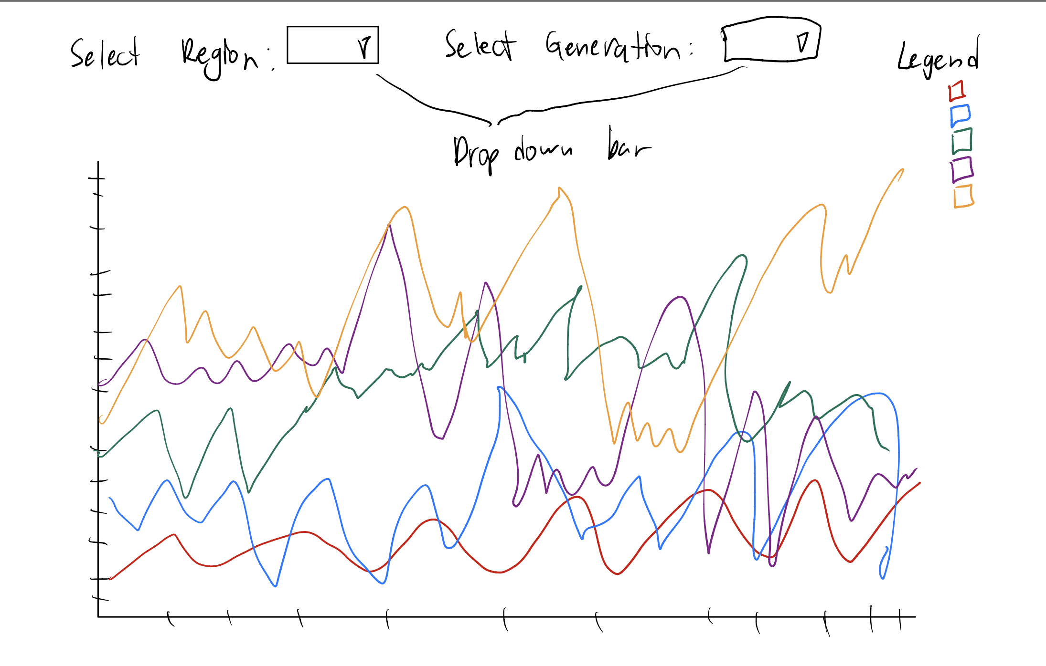(Figure 29: Initial sketch of the Line Chart)

When we were planning out the visualization, we took the data from Kaggle which is a reputable data website. We used a line chart and options to select region, generation, and gender so that users can make comparison more clearly. We are able to see which generations are the ones that get affected by suicide the most. However, later we realized that the chart is way too simple and hard for users to read, so we decided to scrape this idea and change it to circular heat map.

**Fourth Topic:** What is the suicide rate between different age groups in Asia vs Europe?

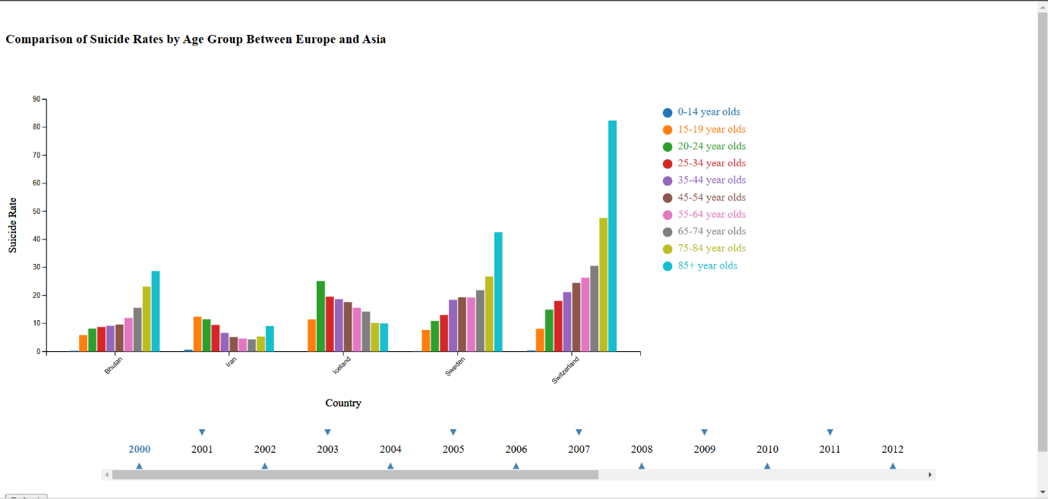  
(Figure 30: Initial Visualization of the Group Bar Chart)

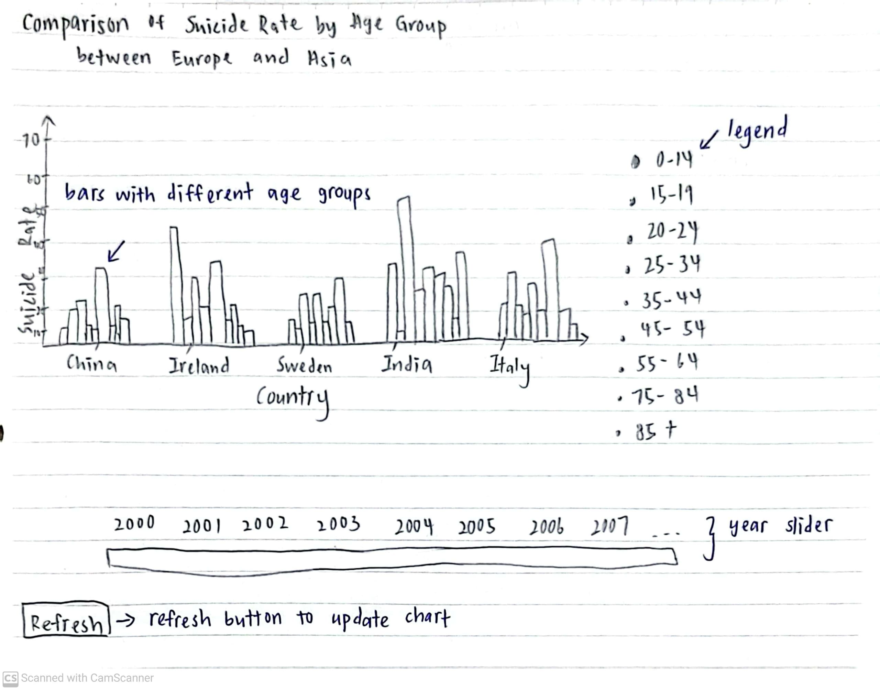

(Figure 31: Initial Sketch of the Group Bar Chart)

To facilitate comparisons between different countries and age groups, we implemented a simple grouped bar chart with a year slider, allowing users to view specific rates or countries in detail. We also added a “Refresh” button under the year slider, which allows users to refresh the chart and view the data for different countries. Furthermore, the legend with colored circle dots offers an easier way for users to distinguish between different age groups, rather than just relying on the tooltip which stated country, continent, suicide rate and age group.

However, we found that the bar chart is too basic and lacks visual appeal. Additionally, the large range of years (from 2000 to 2021) can make navigation troublesome for users.

**Fifth Topic:** Suicide Methods used compared between Asia vs Europe.

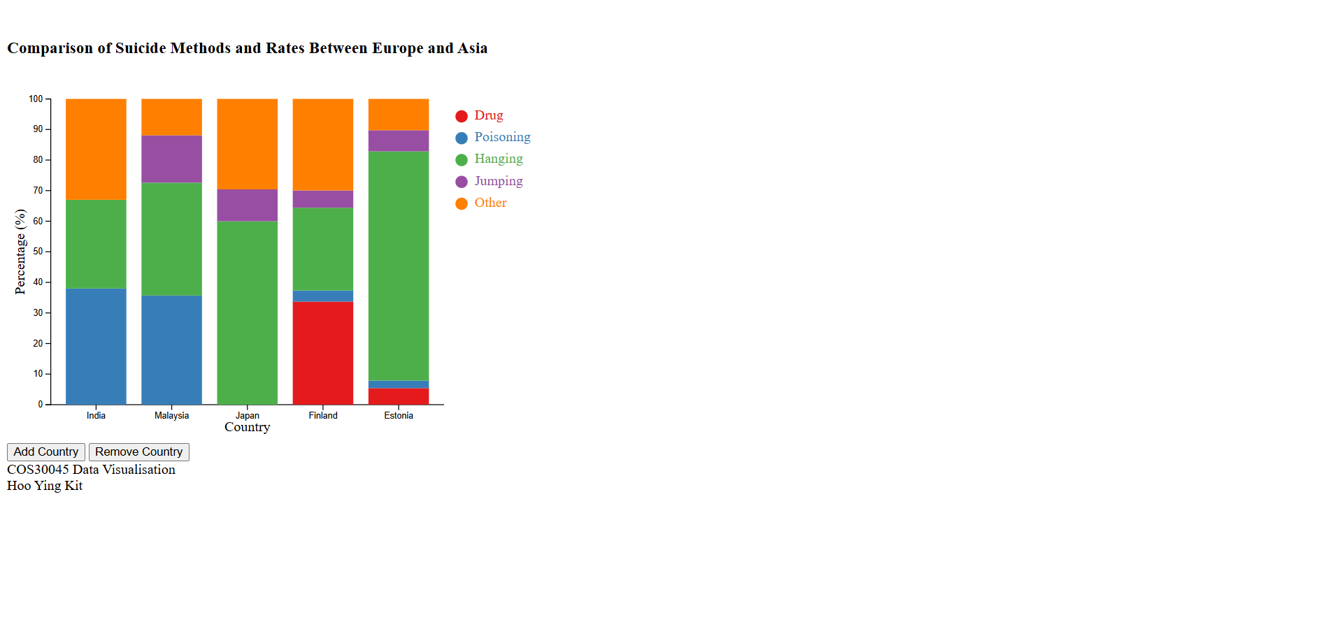

(Figure 32: Initial Visualization of the Sketch Bar Chart)

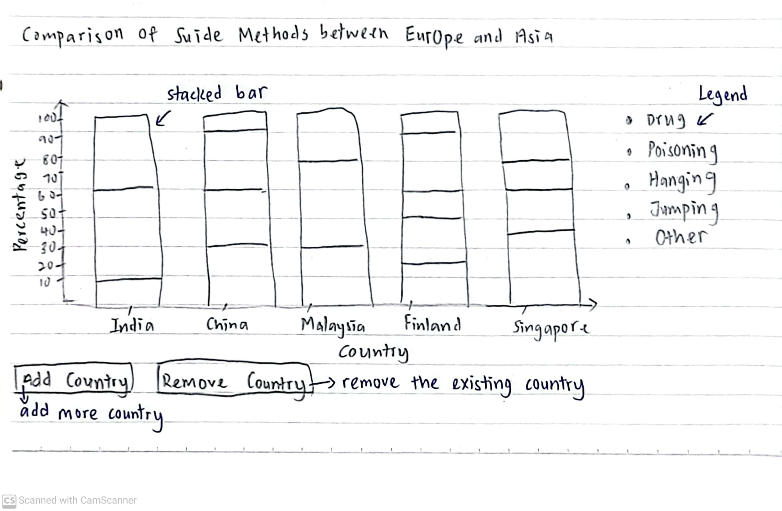

(Figure 33: Initial Sketch of the Stacked Bar Chart)

To compare suicide methods that are used within Asia and Europe, we initially used a stacked bar chart. A stacked bar chart is useful for displaying suicide methods because it allows users to immediately see the percentage of each suicide method in each country. It also makes it simple to compare how various suicide methods are distributed across nations, making it easier to spot trends or variations quickly. The idea is just like this, we haven’t added any hover effects, transitions, or tooltip. However, we did add the options for users to compare more countries by adding country or to compare less countries by removing countries one by one. This is just the initial idea of this topic

## 3.2 Finalized Designs

**First Topic:** What is the Suicide Rate compared between Asian countries vs European countries?

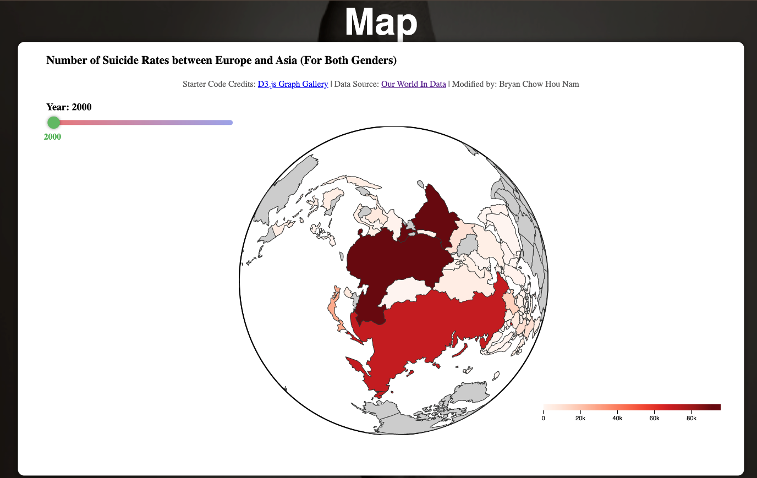(Figure 34: Final visualization for the map chart)

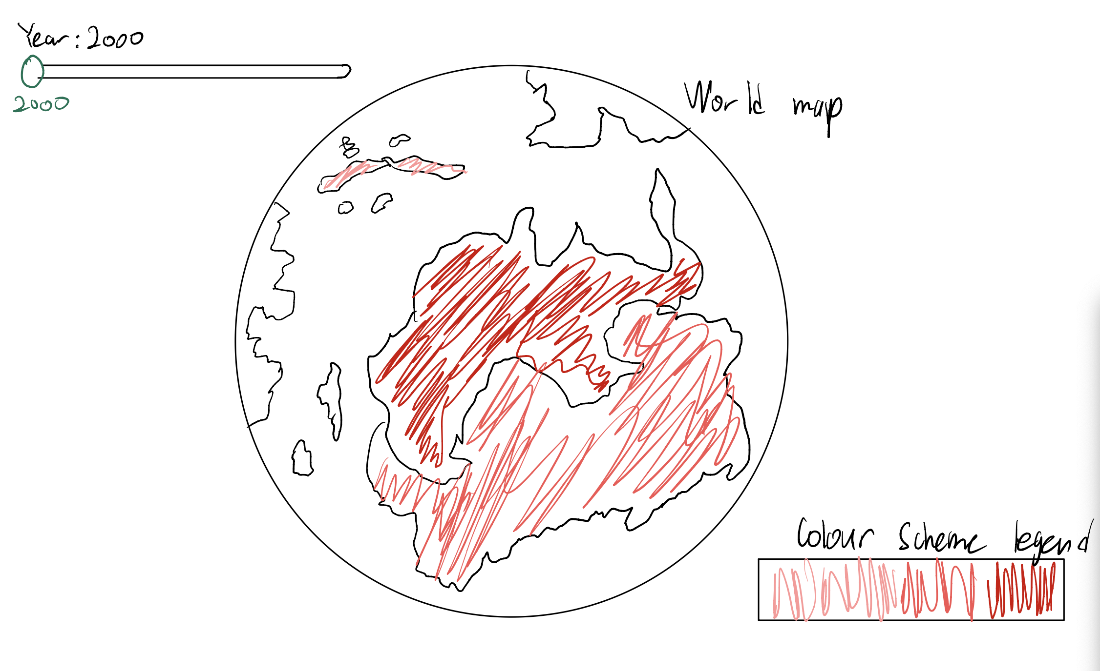

(Figure 35: Initial Sketch of the Finalized Map Visualization)

Before this finalized version of map, we only have the outline of the map, without the colors. Right now, we added a color scheme of the map to show which country has the highest suicide rate. And we turn the entire world map from flat to a globe now to make it nicer and attractive. At the bottom of the chart, we created a color legend to show the scale out of 100,000 people who have suicided. To the top left of the chart, we have added a slider bar which can slide through the year. Each year has a different amount of suicide rate between each country. Besides that, whenever the slider bar changes, the color of the map will change according to the legend.

**Second Topic:** What is the Suicide Rate compared between high, low, upper-middle, lower-middle income level countries in Asia vs Europe?

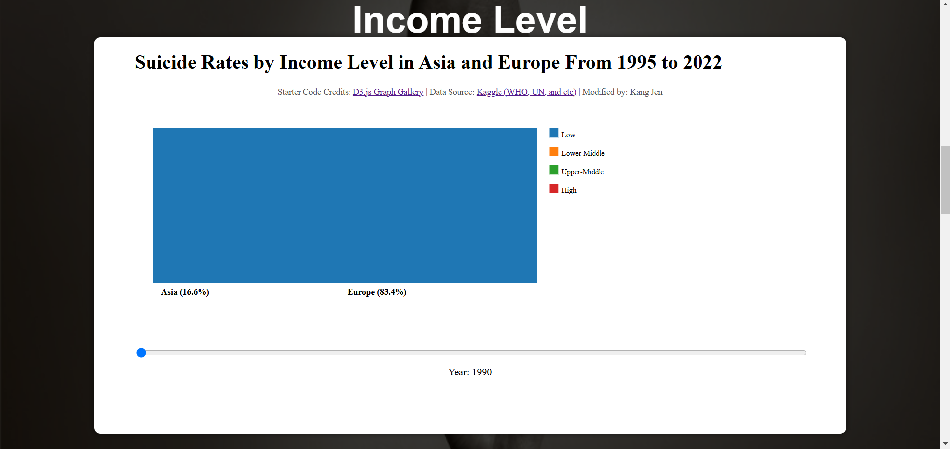(Figure 36: Finalized Visualization Mosaic Plot)

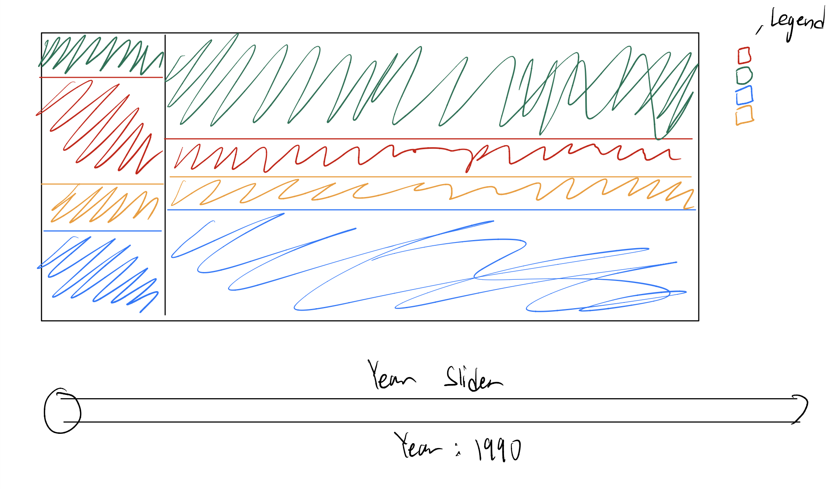(Figure 37: Initial Sketch of the Finalized Mosaic Plot)

After careful planning from us, we decided to change and stick with Mosaic Plot, as this is able to showcase the suicide rates between income level countries in more detail as you can see from the Figure with the percentage of each income level countries suicide rate and how much they contribute to in each region. We also have a legend indicating income levels, with different colors for better clarification. We still keep the slider to ensure the graph is user friendly and added in hover effects and transitions to keep users’ attention in our graphs. We also used colors that don’t collide with the background and blend well. We concluded that over the years suicide rates for low-income countries have gone drastically down while high income countries have gone up. Also, Europe throughout the years has a higher suicide rate compared to Asia.

**Third Topic:** What is the Suicide Rate compared between Generations (e.g. Gen Z, Gen X, and etc) in Asia vs Europe?

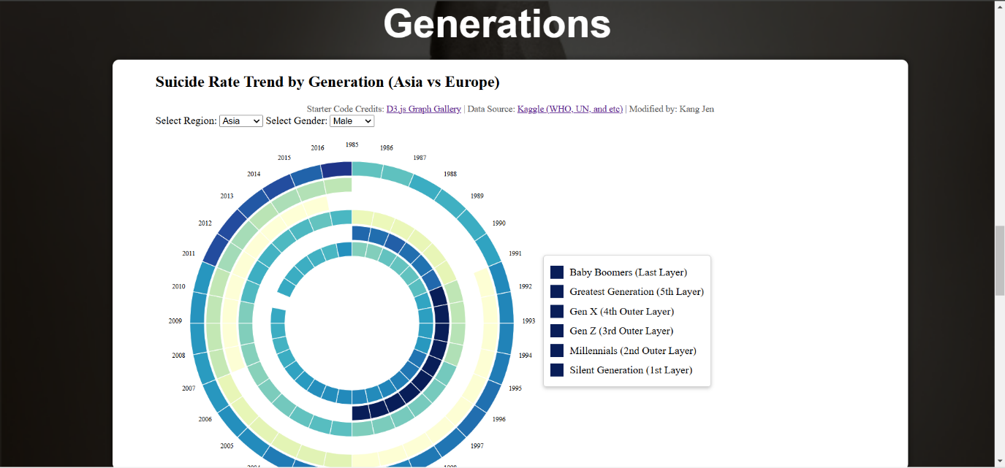(Figure 38: Finalized Visualization Circular Heat Map)

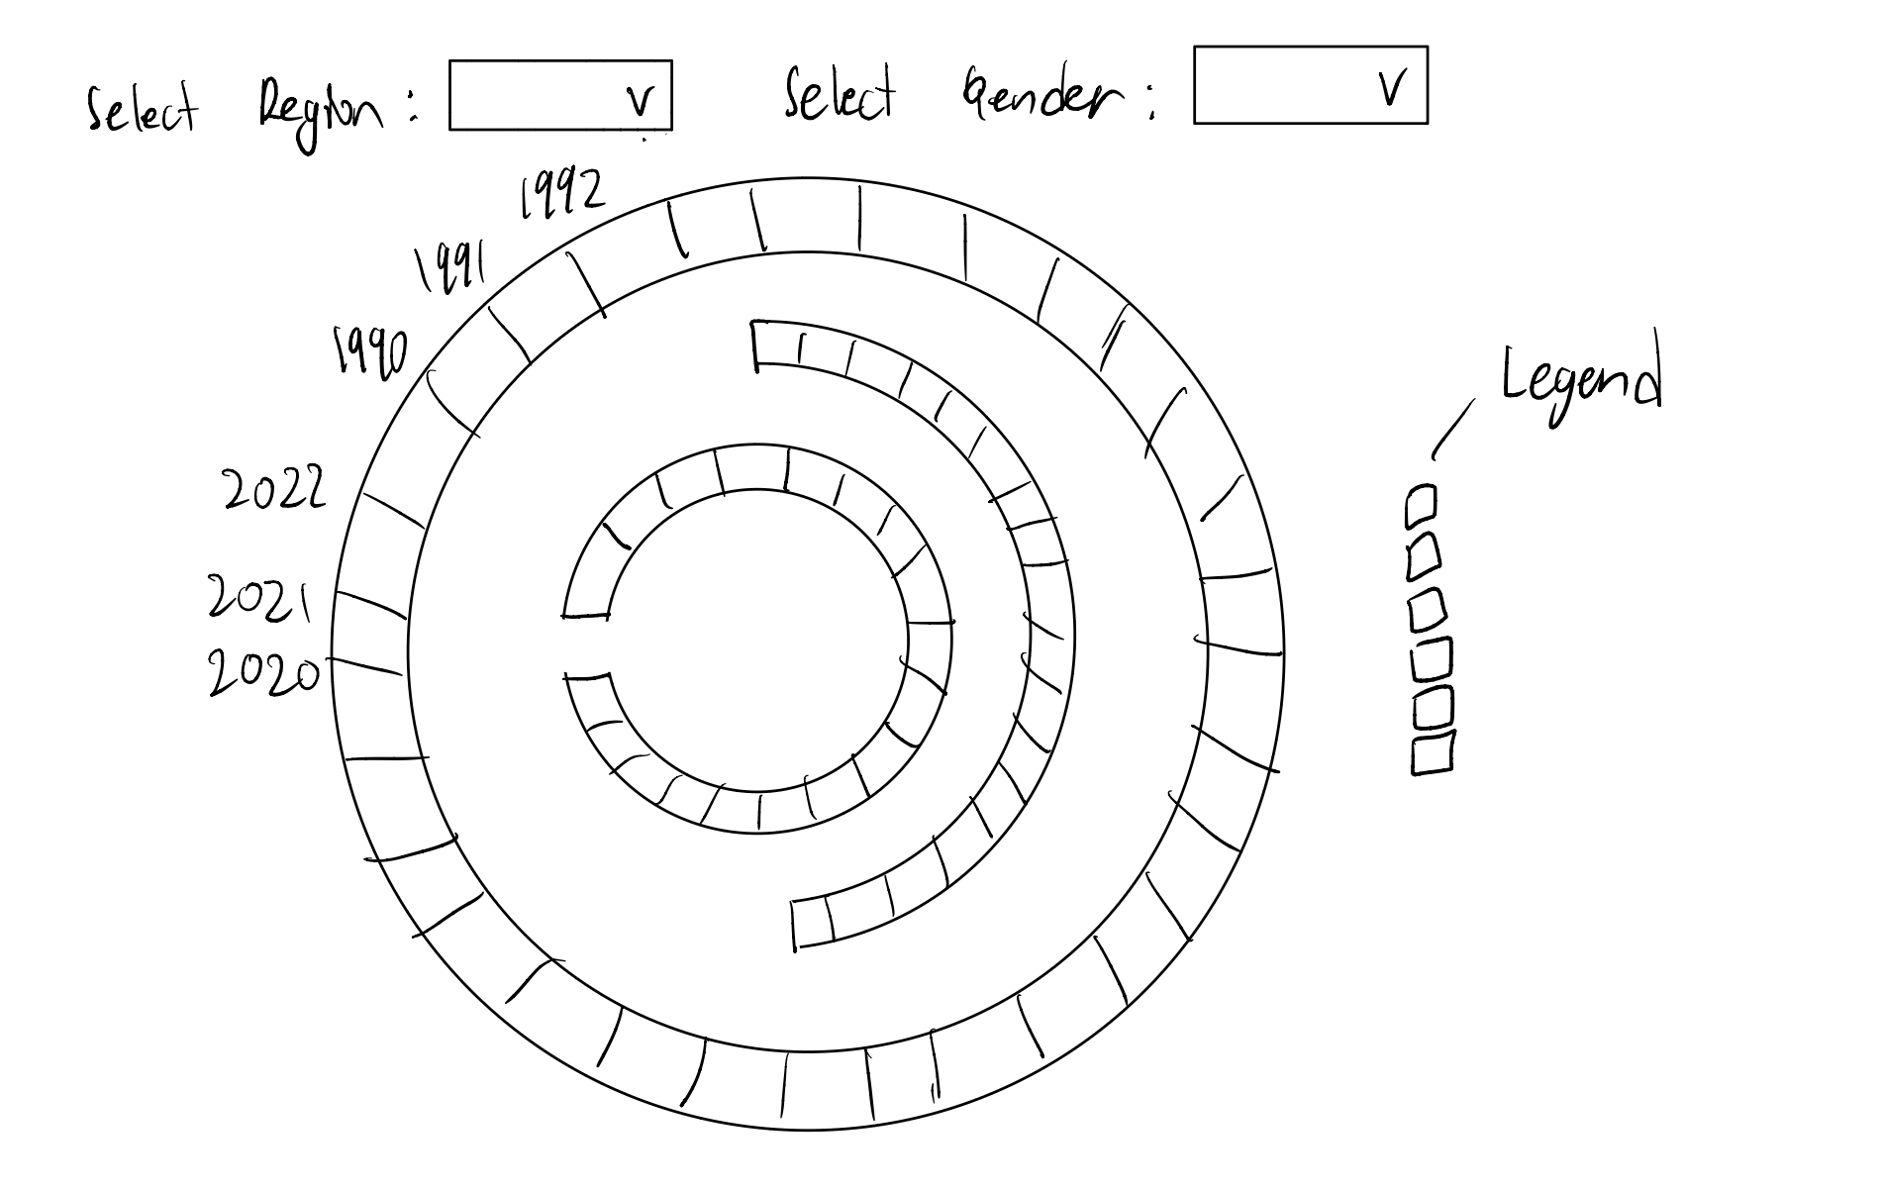(Figure 39: Initial Sketch of the Finalized Circular Heat Map)

After careful planning from us, we decided to change and stick with Circular Heat Map, as this is able to showcase the suicide rates between generations in more detailed, clear, and aesthetically pleasing. So, basically each layer represents a different generation, and each bar represents a particular year of that generation. We also added hover effects when we hover over a bar and a legend that highlights a particular layer when we hover over a generation stated in the legend for clarification. The color gradients that we chose are made sure to blend in with the background, but however I (Kang Jen) did not indicate the purpose of the color gradient which may confuse users that are not familiar with unique. We concluded that over the years suicide rates for G.I. Generation until 2000 has the highest suicide rate in both regions while Gen Z has the lowest in both regions.

**Fourth Topic:** What is the Suicide Rate between different age group in Asia vs Europe

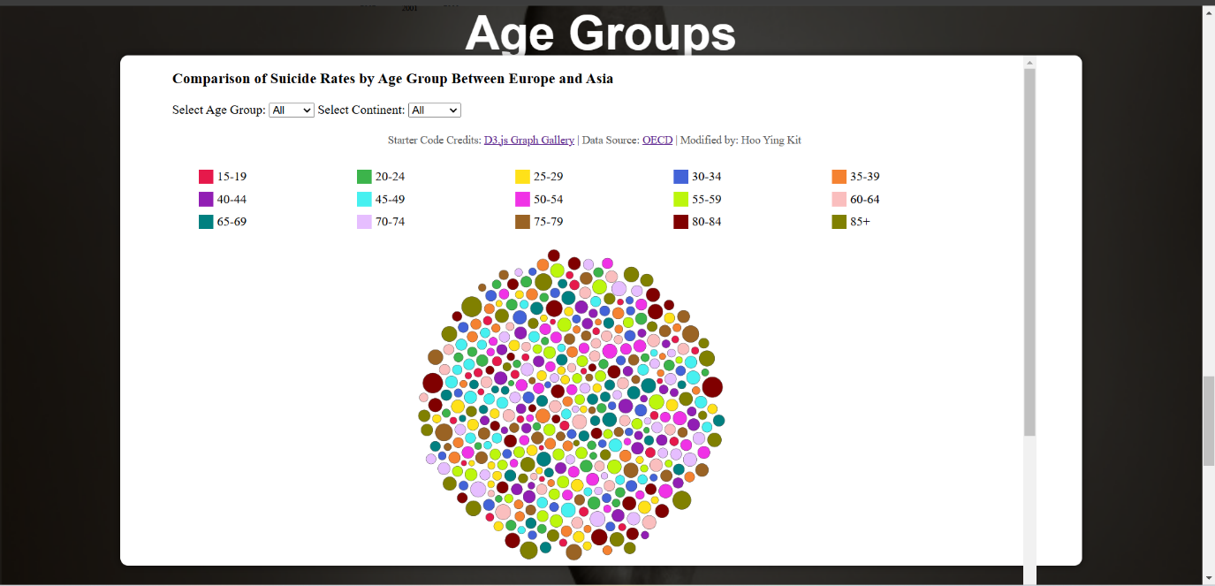  
(Figure 40: Finalized visualization of the Bubble Chart)

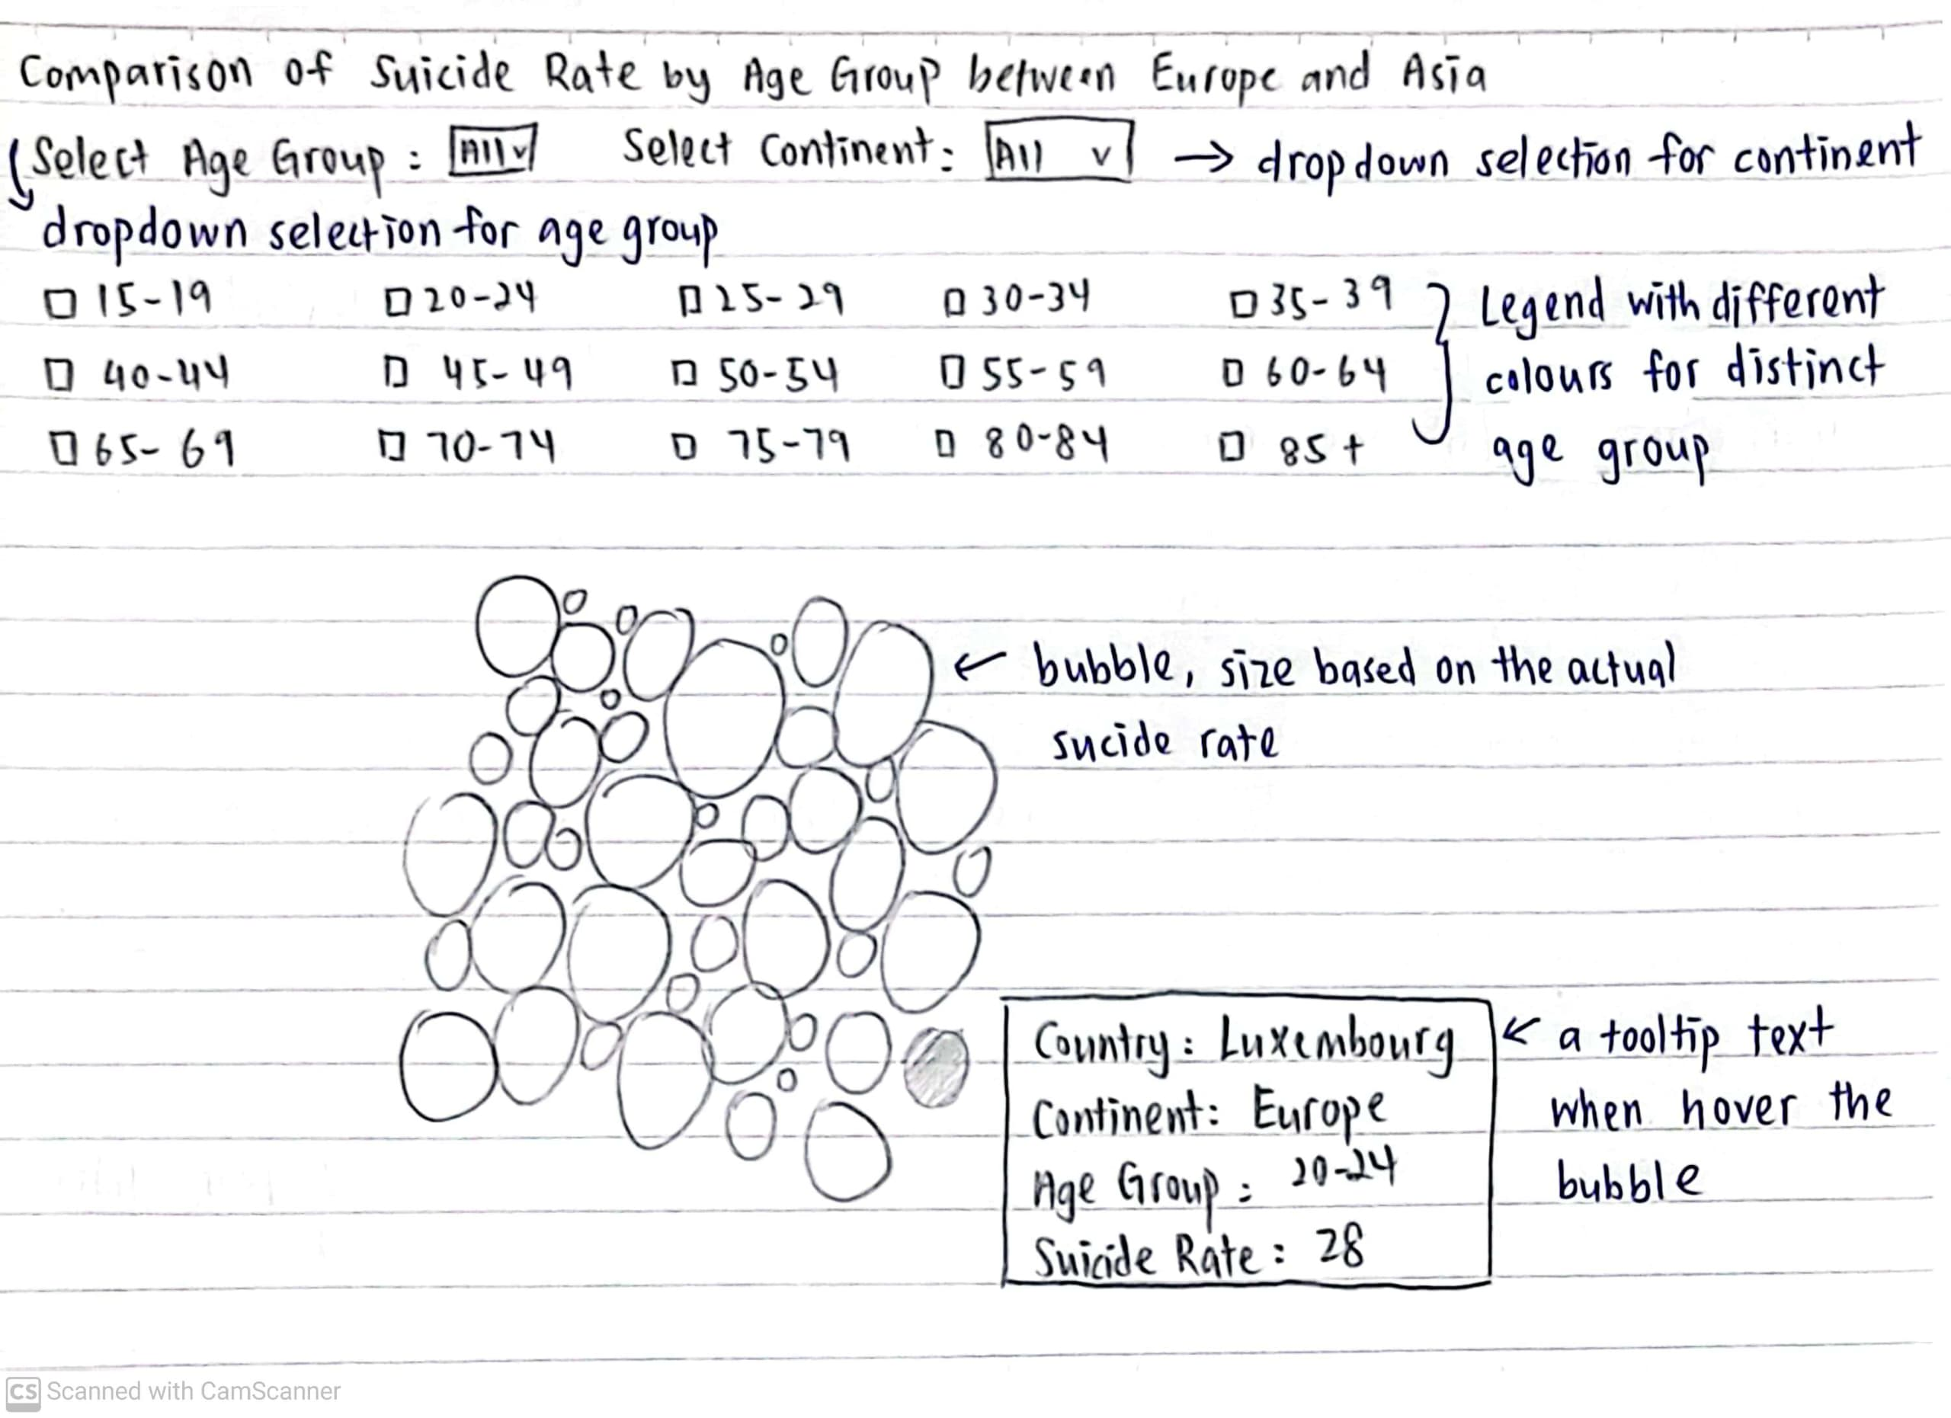

(Figure 41: Initial Sketch of the Finalized Bubble Chart)

After some serious consideration, we decided to change the group bar chart to an interactive bubble chart. This is our decision because bubble chart looks more fun and appealing compared to a group bar chart. We provided options to select between age groups and also region. We added an interactive legend as well where we hover an age group in the legend, that age group will be highlighted. The chart also has the ability to be resized and moved around. Through this movement, users can drag the bubbles in the ways they desired, allowing high freedom such customized the bubble chart. Overall, the chart will be able to provide a valuable insight on suicide rates among age groups while having a good time as well. In conclusion, users can observe the suicide rates of different age groups, which is useful for psychological analysis to address the problem of high suicide rates within specific age groups, helping to prevent individuals from simply giving up on their lives.

**Fifth Topic:** Suicide Methods used compared between Asia vs Europe.

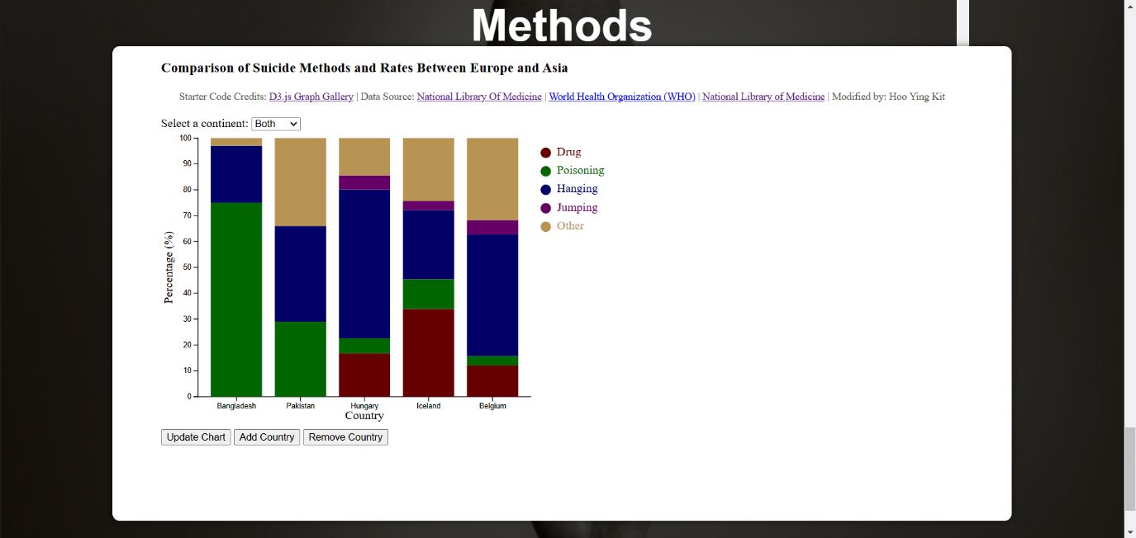(Figure 42: Finalized visualization of the Stacked Bar Chart)

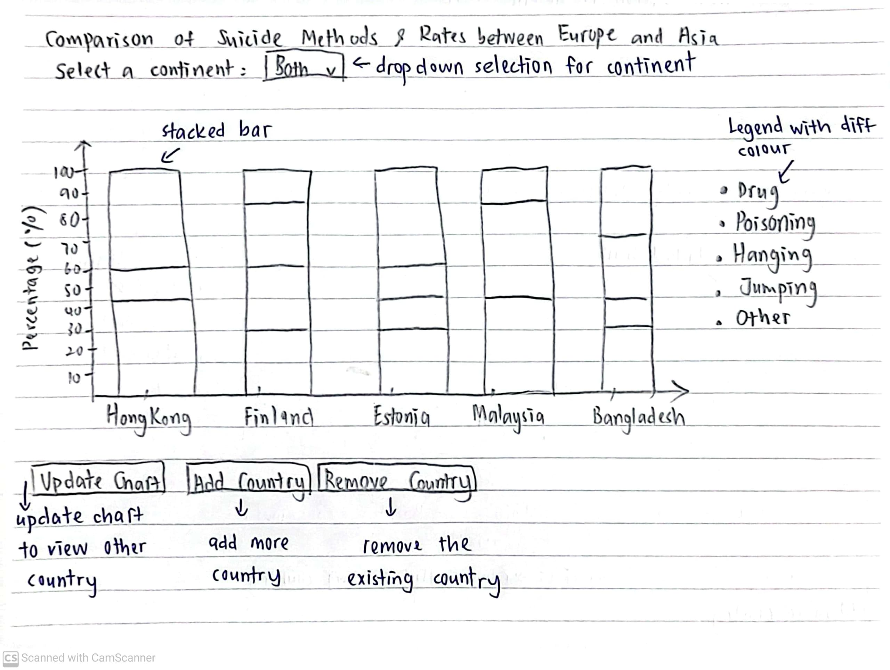

(Figure 43: Initial Sketch of the Finalized Stacked Bar Chart)

After some serious consideration, we decided to keep the stacked bar chart, but we added some features to it. We added hover effects like let’s say when we hover over the poisoning bar, only that particular category will be highlighted. We also added tooltips to indicate the percentage of each category when we hover over the bars. Other than that, the extra options that we added were for selecting continents, whether we would like to compare Asia or Europe, and update charts which is basically to change the countries that we are comparing. We also change the color gradient so that the chart doesn’t look too boring. Not only that, but the hue we picked is similarly dark, emphasizing the seriousness of suicide and expressing the emotional weight connected with discussing such a sensitive topic. Overall, we believe that this chart will enable users to compare suicide methods used between Asian and European countries more effectively compared to the first version of the stacked bar chart.

# 4.0 VALIDATION

To evaluate the usability of our visualizations, we designed a usability test using Google Form. The evaluation involved collecting feedback from participants on the clarity, design, and usability of the website visualizations. Below are the steps taken:

**Method:**

1. **Participants**: We managed to get 6 participants to evaluate our charts, which all of them were students.
2. **Procedure**: Participants were provided a link to the website showcasing the visualizations and asked to interact with each chart, including the map, mosaic plot, circular heat map, bubble chart and the stacked bar chart.
3. **Feedback Collection**: After reviewing the visualizations, participants completed a Google Form that asked questions on:
   1. **Clarity**: Were the visualizations easy to understand?
   2. **Design**: Was the design (colors, labels, legends) visually appealing and accessible?
   3. **Ease of Use**: Was navigating the website and interacting with the visualizations intuitive?
   4. **Insights**: Did the visualizations effectively communicate insights about the suicide rates in Asia vs. Europe?

**Result:**

The feedback provided valuable insights into the usability of the website and visualizations:

* **Clarity**: ["83.3% (5) of participants agree that the visualizations are clear and easy to understand while 16.7% (1) strongly agree."]
* **Design**: ["66.7% (4) of participants said that the styles and font size are easy to read while 33.3% (2) said maybe, taking into cases of color-blind people"]
* **Ease of Use**: ["100% (6) of participants found the navigation work as expected."]
* **Insights**: ["For the insights, it is pretty mixed, 16.7% (1) found our visualizations is just average in terms of usefulness to understand the suicide data, 66.7% (4) thinks it is useful while 16.7% (1) thinks it is very useful "]

**Improvement:**

Based on the feedback that we got from the Google Form, most of them are giving positive responses that like our visualization design and easy to understand. In contrast, some feedback indicates that our website has inconsistent styling and is confusing, particularly regarding the generation of visualizations. The negative feedback provides a good suggestion for our project improvement, as the website’s styling lacks consistency, with different heading styles used in the map and visualization charts. Moreover, the tooltip text needs to be more organized, as the font size is not uniform across all visualizations and maps. Furthermore, the circular heat map, generation legend, and color gradient need to be reorganized. The issue with the legend is that the colors do not match the visualization, while the legend dots are dark blue, but the visualization uses lighter, different shades of blue. In conclusion, we will take everything into consideration and use it to improve our future data visualizations project.

# 5.0 CONCLUSION

This project sheds light on the suicide rate disparities between Asia and Europe, illustrating how socioeconomic, cultural, and healthcare factors contribute to the complexities surrounding this issue. The visualizations provide a thorough, comparative analysis, highlighting variations across different age groups, genders, and regions within Asia and Europe. Through these visual representations, the project explores underlying factors contributing to suicide rates and brings attention to the potential impact of preventative strategies.

The interactive approach used in this report aims to make complex data on suicide rates more accessible, fostering a deeper understanding of the demographic trends and potential risk factors associated with mental health across diverse regions. By visualizing such data, this project encourages more informed discussions around mental health, emphasizing the need for contextually relevant interventions.

In summary, this project underscores the significance of mental health awareness and the necessity for evidence-based approaches to suicide prevention across Asia and Europe. The insights provided can serve as valuable resources for stakeholders, including policymakers, mental health professionals, and researchers, to develop targeted strategies aimed at mitigating suicide rates in different socio-cultural contexts. Through informed decision-making and data-driven strategies, there is a hopeful path toward reducing suicide rates and promoting mental health resilience globally.

6.0 REFERENCES  
  
1. Bostock, M. (2024, October 1). D3 gallery. Observable. [https://observablehq.com/@d3/gallery?utm_source=d3js- org&utm_medium=hero&utm_campaign=try-observable](https://observablehq.com/@d3/gallery?utm_source=d3js-%20org&utm_medium=hero&utm_campaign=try-observable)

2. *Suicide Rates & Socioeconomic Factors (1990 - 22)*. (2024, March 14). Kaggle. <https://www.kaggle.com/datasets/ronaldonyango/global-suicide-rates-1990-to-2022>

3. *Suicide Rates Overview 1985 to 2016*. (2018, December 1). Kaggle. <https://www.kaggle.com/datasets/russellyates88/suicide-rates-overview-1985-to-2016>

4. Suicide and Suicide Prevention in Asia

<https://iris.who.int/rest/bitstreams/52201/retrieve>

5. Suicide methods in Asia: Implications in suicide prevention. (n.d.). PMCHome.

<https://pmc.ncbi.nlm.nih.gov/articles/PMC3366604/#sec2>

6.Suicide rates generally increase with age. (n.d.). OECD iLibrary.

<https://www.oecd-ilibrary.org/social-issues-migration-health/suicide-rates-generally-increase-with-age_5b4fab1f-en>

7.Table - PMC. (n.d.). PMC Home.

<https://pmc.ncbi.nlm.nih.gov/articles/PMC2569832/table/HZT-62-06-0545-t02/>

8. Lee, L., Roser, M., & Ortiz-Ospina, E. (2019). Suicide. Our World in Data. <https://ourworldindata.org/suicide>

‌

# 7.0 APPENDICES

* Usability Evaluation Test Materials

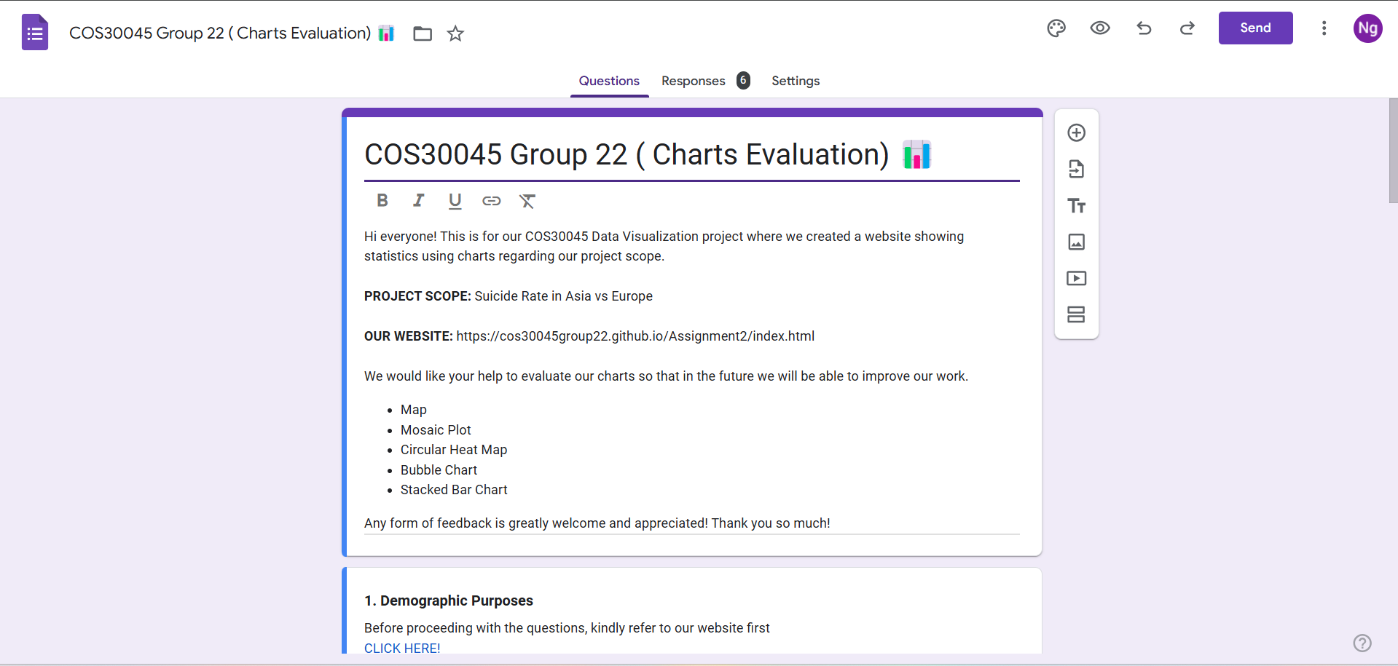Figure 44: Our Google Form [(https://docs.google.com/forms/d/e/1FAIpQLSeuKUUgU2SkutL7UAWz3EltgE-uoGl7Bo0J2C5qDeOSiVh8Vw/viewform?usp=sharing)](https://docs.google.com/forms/d/e/1FAIpQLSeuKUUgU2SkutL7UAWz3EltgE-uoGl7Bo0J2C5qDeOSiVh8Vw/viewform?usp=sharing)

* Notes/data collected in usability evaluation

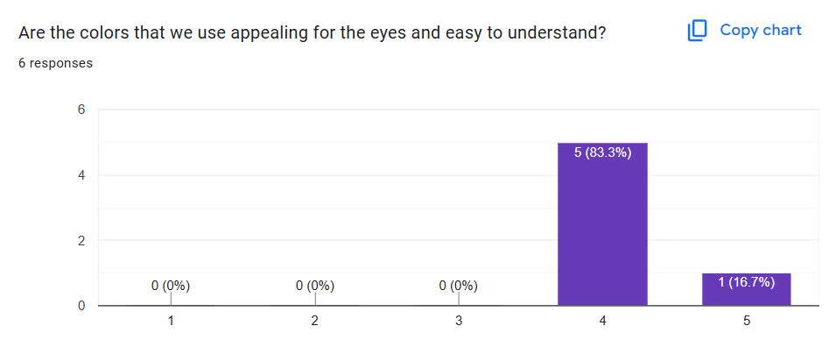  
(Figure 45: Clarity)

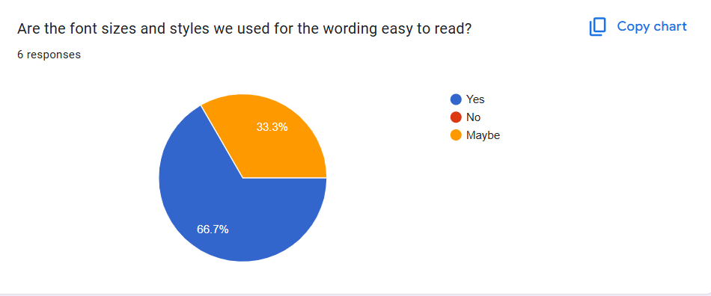(Figure 46: Design)

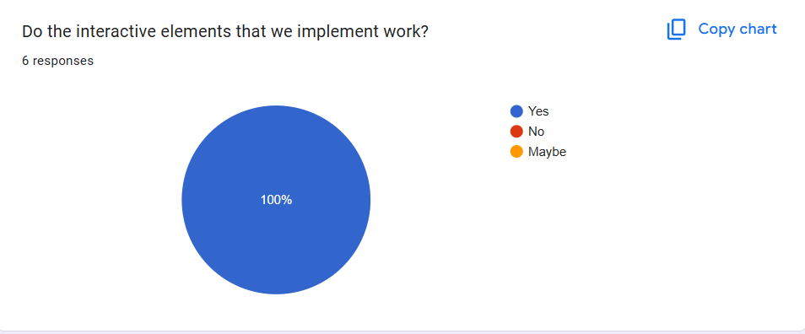(Figure 47: Ease Of Use)

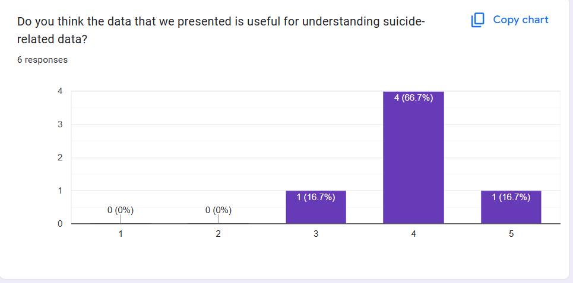(Figure 48: Insights)

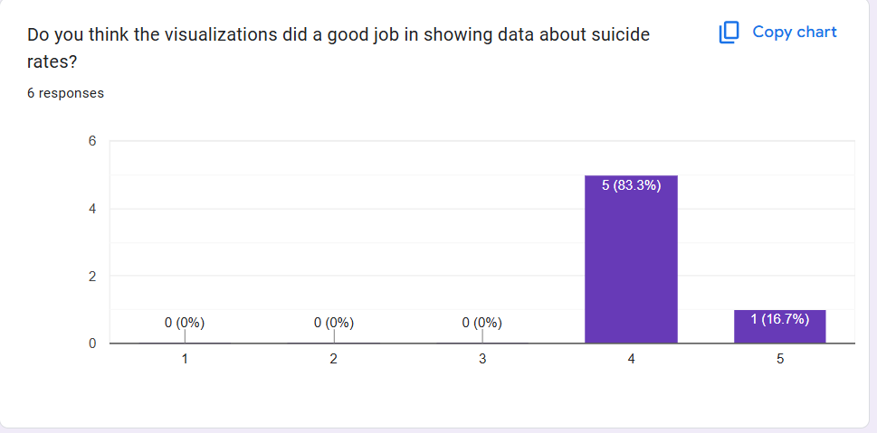(Figure 49: More about Insights)

## 